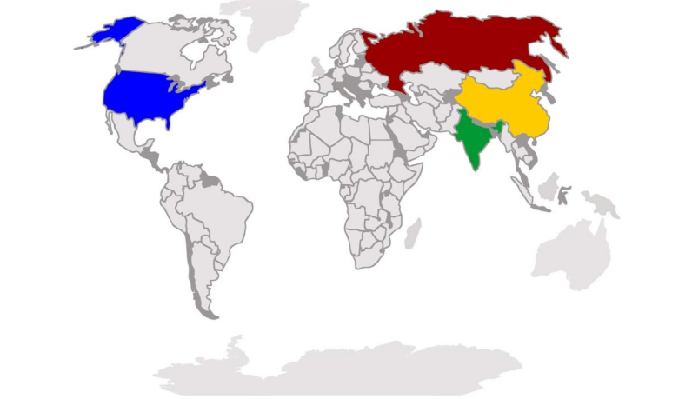



**CRISIS MANAGEMENT**

**AND**

**EXECUTIVE DECISION-MAKING**

**SIMULATION EXERCISE**



**2 0 2 2**

**CDR ANTHONY R DE LEON**

**CREATOR/FACILITATOR**

**OIC - NAVAL FORCES RESERVE NORTHERN LUZON**

**FOR**

**122ND NAVAL COMBAT SUPPORT SQUADRON RESERVE**

**12th NGR, NFR-NL**

**Objectives of the Exercise**

The process of decision making is of the utmost importance for effective management. As a manager and leader, your decision-making must be informed by expert knowledge and experience. It is in this context that the exercise was designed primarily to bring out abilities in making sound decisions specifically in the face of crisis.

Secondary aim is for the participants to achieve their respective objectives within the bounds of ethics and moral standards and apply the principles of teamwork and leadership all throughout the process.

|  |  |  |
| --- | --- | --- |
| **Table of Contents** | | |
| **Objectives of the Exercises** |  | 2 |
| **Introduction** |  | 6 |
|  |  |  |
| **I Rules of the Exercise** |  | 7 |
|  |  |  |
| **II Team Objectives** |  |  |
| Red Team Objectives |  | 9 |
| Blue Team Objectives |  | 11 |
| Yellow Team Objectives |  | 13 |
| Green Team Objectives |  | 15 |
| United Nations Objectives |  | 17 |
|  |  |  |
| **III Assessment for Victory and Defeat** | | |
| Red Team |  | 18 |
| Blue Team |  | 19 |
| Yellow Team |  | 20 |
| Green Team |  | 21 |
| United Nations |  | 22 |
|  |  |  |
| **IV Rules of Engagement** |  | 23 |
|  |  |  |
| **V The Doctrine of "MAD"** |  | 25 |
|  |  |  |
| **VI Definition of Terms** |  | 26 |
|  |  |  |
| **VII Roles** |  |  |
| Red Team |  | 31 |
| Blue Team |  | 33 |
| Yellow Team |  | 36 |
| Green Team |  | 38 |
| United Nations |  | 40 |
|  |  |  |
|  |  |  |
|  |  |  |
| **VIII Capabilities** |  |  |
| Red Team |  | 41 |
| Russian Military Capabilities |  | 45-64 |
| Blue Team |  | 65 |
| US Military Capabilities |  | 69-89 |
| Yellow Team |  | 90 |
| China Military Capabilities |  | 92-120 |
| Green Team |  | 121 |
| India Military Capabilities |  | 122-140 |
|  |  |  |
| **IX Resources** |  |  |
| Red Team |  | 141 |
| Blue Team |  | 149 |
| Yellow Team |  | 161 |
| Green Team |  | 169 |
|  |  |  |
| **X Correlation of Forces** |  | 174 |
|  |  |  |
| **XI Coalition of Forces** |  | 175 |
|  |  |  |
| **XII Cities and Population** |  |  |
| Russian Cities |  | 176 |
| Allied Cities |  | 178 |
| Cities of China |  | 179 |
| Cities of India |  | 180 |
|  |  |  |
| **XIII Annexes** |  |  |
| A – Additional Scenarios |  | 183 |
| B – Symbols |  | 184 |
| C - Maps |  |  |
| Facilitator |  | 186 |
| Red Team |  | 187 |
| Blue Team |  | 188 |
| Yellow Team |  | 189 |
| Green Team |  | 190 |
| D – Templates for Communication | | |
| Red Team |  | 191 |
| Blue Team |  | 192 |
| Yellow Team |  | 193 |
| Green Team |  | 194 |
| |  |  |  | | --- | --- | --- | | E - Nuclear Plant |  |  | |  | 195 |
| F- Launch Codes |  | 196 |
|  | | |
| **XIII Secretariat** |  | 197 |

**INTRODUCTION**

“From time immemorial, the purpose of the Navy has been to influence, and sometimes to decide, issues on land. This was so with the Greeks of Antiquity, the Romans who created a navy to defeat Carthage, the Spanish whose Armada, tried and failed to conquer England and most eminently, in the Atlantic and Pacific during two world wars. The sea has always given man, inexpensive transport and ease of communication over long distances. It has also provided concealment, because being over the horizon meant being out of sight and effectively beyond reach. The sea has supplied mobility, capability, and support throughout Western history, and those failing in the sea power test – notably Alexander, Napoleon and Hitler – also failed the longevity one.”

-Edward L. Beach *Keepers of the Sea*

**I RULES OF THE EXERCISE**

1. Teams are not allowed to listen or watch the plans & decisions of opposing teams.
2. Team players **ARE NOT ALLOWED** to plot the map or change the location of the symbols. Only the plotters are allowed to move the symbols. Teams should analyze and use the map as a planning and decision tool.
3. Game time duration is strictly 9 hours (8:00am-5:00pm). 1 hour is equivalent to 1 day. 30 minutes is equal to 12 hours. A timer is assigned for the exercise.
4. All Command and Control Structure Members shall always be together and **MAY NOT**  be separated unless, one or several defect to another team or an assigned representative is designated to attend meetings in the UN.
5. All decisions and movements shall be printed by the assigned staff of the Secretary of State or Foreign Minister based on format provided by facilitators. A copy of printed decisions/movements shall be given to designated facilitators only.
6. All orders, decisions and movements shall be printed and submitted to the facilitators as soon as possible then facilitated only if they are valid and specific. (Annex D)
7. All orders and movements are considered invalid if they are not signed by the Head of State.
8. Communiqués or messages to be given to opposing force are allowed and are valid as long as they pass through the facilitators.
9. A Hotline shall be provided to all Teams and each team can communicate directly through this provided medium. Any or all the parties may have the option to use this Hotline. Using other forms of medium to directly communicate with each other is not allowed.
10. Participants are not allowed to post anything in social media with regards to this exercise. Only the facilitators of this program shall designate the authorized person to post the progress and completion of this exercise.
11. Any party can initiate or terminate negotiations. Negotiations may be conducted in the Negotiating table of the United Nations or through the Hotline. The UN Secretary General shall be designated as mediator/facilitator.
12. Deployment of assets or resources should be specific in terms of type, mission, targets/s and grid location.
13. Advisers should recommend increasing or decreasing alert levels, movements and deployments but **ALL** and ultimate decisions shall only be made by the Heads of State. No deployment and/or movement shall be made without the express and signed approval by the respective Heads of the State.
14. The facilitators are the only group who will report the success or failure of each mission, tactical or strategic. Kills will be recorded by the facilitators, however, each team may record win/loss ratio of their group.
15. A correlation of forces shall be provided for each team.
16. At any time during the exercise, the teams **CANNOT** ask questions to the facilitators.
17. Meals shall only be partaken inside each team’s territory. Toilet users should proceed to the restroom and return immediately to the game venue. There is no time out. Marshals will be provided for compliance.
18. A change of leadership can only be undertaken if it is a majority vote (Democratic means) and/or coup d’ état.
19. The Heads of State may relieve or put under arrest any team member who is found to be incompetent or has committed acts of treason/espionage.
20. Even during high intensity conflict, diplomacy can be utilized for negotiations, clarifications & settlement/cessation of hostilities.
21. At any time during the exercise, any team that submits the instruments of surrender, shall be accepted by the victorious team.
22. Destruction of Cities with the use of nuclear weapons by teams no matter how many will constitute a strategic stalemate.
23. Even if the teams obliterate their respective opponents, it will constitute a strategic stalemate. Destroying the other team’s location and negating the Command and Control Authority will not stop a Nuclear War but will lead to further destruction of and by both sides. Each side has a pre-programmed order to totally release all nuclear weapons in their arsenal. Therefore, it is incumbent for both sides to pursue peace and immediate cessation of hostilities even if a thermonuclear or conventional war has already started.
24. The assessment for total victory shall be used to determine the victor and loser.
25. Other rules shall be implemented by the facilitators as the need arises.

**II OBJECTIVES**

**RED TEAM**

It is 2011, a decade since the 9/11 terror attacks in New York, Virginia and Philadelphia, USA.

The Russian Federation, after the collapse of the Soviet union, has started its economic recovery due to aggressive oil exploration, and diamond mining in Siberia. However, its Military is still suffering from degradation after the rebellion and is still trying to control former Soviet Republics, namely Ukraine, Latvia, Lithuania, Estonia, Georgia and Khazakhstan.

However, even with the Russian armed forces in a state of disrepair, it is still conducting cold war tactics against the West. The FSB, which is the successor of the KGB and the GRU, Russia’s Military Intelligence, is supporting Islamic Extremist to undermine the efforts of the United States in the Middle East, particularly in Syria and Afghanistan. It is against Iran, a southern neighbor from developing its own Nuclear Weapons which is quietly supported by China. The Russian leader has undertaken draconian measures to silence its opposition, purge perceived disloyal Russian armed forces generals, and has set up a clique of cronies composed of new oligarchs whose wealth was generated through corruption and establishment of the new Russian Mafia, after the fall of the Soviet Union.

In the meantime, since the Russian oppressive government has focused on rebuilding its armed forces, its calamitous agricultural policies have driven the vast population of this country to the brink of famine and chaos.

Russian hardliners are advising its president to move against NATO, undermine the US Military, and aggravate US-SINO relations.

The bulk of Russian monetary resources are focused on the development of 5th generation fighters, strengthen Cyber warfare, and establish dominion in the Middle East and Europe.

Russian exiles that have been debriefed by US intelligence agencies have received reports that the Russian President is mentally unstable, with health deterioration due to brain cancer and is capable of launching a first strike attack against US, NATO Allies and China in any order.

The nuclear clock is nearer the 12 o’clock time for Armageddon.

**RED TEAM OBJECTIVES**

1. Negotiate a grain deal with the United States without compromising its Nuclear Capability.
2. Control and counter possible Chinese invasion.
3. Negotiate and prevent a nuclear deal between China and Iran.
4. Negotiate and prevent a nuclear deal between China and North Korea.
5. Quarantine with naval vessels the United Kingdom and Iceland.
6. Isolate Greenland and take over all airfields in Iceland.
7. Prevent capture of Russian assets in Syria, Iraq and Afghanistan.
8. Prevent take over by US of Syria.
9. Prevent Chinese expansionism in Northwest Pacific to protect Vladivostok and Kamchatka Peninsula.
10. Take over the Crimean Peninsula in Ukraine.

**II OBJECTIVES**

**BLUE TEAM**

Even after the 9/11 terror attacks, the United States stands as the lone superpower in the world after the disintegration of the Soviet Union. Reeling from the unprovoked attacks from Al Qaeda, the United States is facing a two-front war namely Iraq and Afghanistan that are both conducting guerilla warfare on all US occupied regions. It has been reported that the GRU is providing material for warfare and intelligence against US armed forces, assets, and puppet governments.

This is ironic because when Russia invaded Afghanistan in 1979, it was the CIA that was funding the Taliban to fight the Russians. And clearly fortunes have reversed. At the home front, Homeland defense, FEMA, CDCP are bracing for possible and further terror attacks, possibly suicide bombers, cyber attack, and biochemical warfare. The US is also losing from the trade war against China, and is weakened with huge budget deficits due to the on-going two-front war. At the same time, its weak foreign policy has caused the Chinese government to become more aggressive in its maritime claims in the West Philippine Sea and preparing for an all-out invasion of its neighbor Taiwan, described by Chinese officials as not sovereign, but a renegade province.

NATO was formed at the height of the Cold War in 1949 by the Allied Powers, but is weakened by France due to its desire to pull out from the Alliance due to budget constraints.

In the meantime, Russia has started exploratory talks with US Commerce and Agricultural Officials for the purchase of grain to feed its population. On the other hand, the US demands reduction of Russian Nuclear forces in exchange for grain and the pull out of Russian advisers in Syria, Afghanistan and Iraq.

The Central Intelligence Agency is besieged by congressional investigations for its failure to prevent the 9/11 attacks. Its credibility is further eroded by the courts from sources that the agency and possibly high levels of government have been penetrated by Russian and/or Chinese Agents.

The White House is constrained to conduct a witch hunt from within removing its focus on global issues. On the other hand, the armed forces of the United States, continues to modernize and expand its Military, particularly its capability in weaponizing space, conduct cyber warfare and maximize drone warfare.

Finally, the United States shall be constrained to declare war against the Chinese and invoke the Mutual Defense Treaty should China Invade Taiwan and the Republic of the Philippines.

**BLUE TEAM OBJECTIVES**

1. Negotiate a peace settlement between China and Russia regarding possible conflict in Central Asia whereby 12,000 US Marines are stationed.
2. Negotiate with Russia a grain deal but with a 50% reduction of Russian ICBMs totaling currently at 760 missiles.
3. Prevent Chinese expansionism in Southeast Asia.
4. Discover who is the top level mole/spy in the US whether handled by the Russians and/ or Chinese.
5. Prevent the Iranian and North Korean development of Nuclear Weapons.
6. Prevent China from obtaining an oil pipeline from Iran going to China.
7. Influence a Russian or Chinese top level official to defect to the US.
8. Prevent Russian expansionism in the North Sea and North Atlantic.
9. Prevent disintegration of NATO.
10. Negotiate a deal with India US-made weapons for a naval port in Berhampur.

**II OBJECTIVES**

**YELLOW TEAM**

The Chinese have never forgotten or forgiven the European powers “including” Russia and the United States for interfering and collaborating against the Qing Dynasty during the Boxer Rebellion in early 20th century and especially the United States for supporting Generalissimo Chiang Kai-sheck and his Koumintang Government against Mao Zedong after World War II.

The Chinese have never forgotten or forgiven Japan also for its invasion of Mongolia , invasion of Mainland China, the rape of Nanking and other atrocities. Presently Japan is a close ally of the United States.

After decades of continuous revolution and purges, the Chinese government has evolved into a major player in the global stage, especially after government reforms caused by the Tiananmen Massacre.

Its aggressive trade policies, have converted the Chinese economy and has contributed to its massive buildup of its military. It also shows the world that it can be a country with two systems, with Hongkong as an example. However, due to its growing population, now at 1.45B, it needs to expand its territories, exerting influence in Central Asia, the Middle East, Africa, and South Africa.

One of its primary goals to show its superpower stature is to reclaim the province they describe as Taiwan and control of the Taiwanese Strait and the South China Sea (China does not consider it as West Philippine Sea).

As we all know the South China Sea/West Philippine Sea is a vital sea lane of commerce with billions of dollars passing through to provide commerce and trade in Asia, India, Middle East, Australia and Africa.

China needs to import oil to feed its fossil-burning dependent economy, from Kazakhstan. It has stationed a million troops between the border of China and Kazakhstan claiming to protect Chinese immigrants and Chinese ethnic population being persecuted by Kazakhstan citizens. Kazakhstan being a former republic of the Soviet Union is seeking aid from Russia to protect its oil interests. This may be a major hotspot in central Asia.

Continuing border clashes between China and India threatens the Asian subcontinent with China clearly funding India’s poorer neighbor Pakistan.

The Chinese who invented the Art of War believes that in the next quarter century, they can control the better part of Asia and portions of the Asia Pacific Region. It is a belligerent superpower that has always viewed the Russian from the North, the Americans from their eastern seaboard and the Indians in their Southern border as major threats against their global ambitions.

The Chinese have also fully utilized their foreign intelligence service to undermine American, Russian and Indian governments, and have always successfully conducted military and industrial espionage against these three superpowers.

China is covertly facilitating the development of nuclear weapons for North Korea and is negotiating with the Ayatollahs for the development of a nuclear reactor in Iran in exchange for an oil pipeline.

It is now the Chinese Politburo’s objective to execute its strategic Plan to control Central and South East Asia.

**YELLOW TEAM**

1. Invade Kazakhstan after two days of negotiating with Russia.
2. Quarantine Taiwan Strait and West Philippine Sea after three days of negotiating with the US.
3. Provide nuclear weapons to Iran and send through their aircraft carrier Liaoning Battle Group.
4. Provide nuclear weapons after four days of negotiating with the US to North Korea through air transport using Xian Y-20.
5. Invade Taiwan after five days of operations.
6. Agitate Pakistan to declare war against India.
7. Prevent Russia and US from entering a grain trade deal. Let the Russians suffer famine.
8. Release biological weapon after six hours of operation to US, Russia and India.
9. Undertake a massive border skirmish against Indian border troops and eventually start building a naval dock in Myanmar.
10. Recruit an Indian top level official to be an agent of the Chinese Foreign Intelligence Service and defect to China.

**II OBJECTIVES**

**GREEN TEAM**

India was a former British Colony which began in 1888 but regained its independence after the British pulled out of the subcontinent in 1947. But they divided the country into two because of religion. Hence, the formation of the country of Pakistan (which is an Islamic country) and India (a country that practices Hinduism).

However, even with the division of the two countries, both were engulfed in a civil war, which killed millions of Pakistanis and Indians. Notwithstanding its independence from Great Britain, it has established diplomatic and trade ties with Great Britain and the United States. At some point, it also bought military hardware from the former Soviet Union and China.

In January of 1957, with its highly independent and progressive Prime Minister Jawaharlal Nehru inaugurated its first fission reactor thereby making India a nuclear power. It has also started creating its own military industrial complex following the footsteps of the three major superpowers and started building its own indigenous military war materiel.

India has a constant distrust and national paranoia against China which it believes to be fanning the flames of conflict between its country and Pakistan. And Pakistan, which is its mortal adversary also became a nuclear power in 1998, which it believes the material and technology was provided by the Chinese. The threat of Chinese expansionism may eventually lead to control of the Bay of Bengal since Laos, Myanmar are already puppet states of China. Should the Chinese put up a port at the Bay of Bengal they will now be considered as a Bluewater Navy threatening Australia, the Middle East, Africa and India.

India must now exert all means to weaken Pakistan, Myanmar, Laos, to thwart the domination of the Chinese in the Indian subcontinent and Bay of Bengal.

Chinese intelligence services have also penetrated the upper echelons of the Indian government and is in the same boat as its counterpart in the US. On the other hand it will continue to use Russia as a trading partner to put a check against Chinese expansionism.

India recently launched its aircraft carrier named Vikraant.

**GREEN TEAM OBECTIVES**

1. Negotiate with the US for US-made weapons in exchange for naval base in Mumbai.
2. Prevent expansionism in the Bay of Bengal by China that intends to put up a naval port in Myanmar.
3. Prevent the blockage of the South China Sea/West Philippine Sea by the Chinese naval forces.
4. Weaken Pakistani armed forces that support Islamic Terrorists.
5. Discover who the high-ranking Indian official that is a mole/spy of the Chinese government.
6. Strengthen border troops along the Indian-Chinese line.
7. Negotiate with Russia for grain in exchange for Russian intervention against Chinese aggression.
8. Immediately position the newest aircraft carrier of India in the Taiwan Strait.
9. Defend and if necessary, totally annihilate Pakistan for any form of aggression.
10. Prevent China from acquiring an oil pipeline from Iran.

**II OBJECTIVES**

**UNITED NATIONS**

The United Nations currently based in Manhattan, NY City was founded in June 1945, and its charter was completed in October of the same year.

The predecessor of the United Nations was The League of Nations which was an utter failure for it did not deter the Axis Powers to conduct war against its neighboring countries.

The UN, for brevity, founded by the original Allied Powers currently has a membership of 193 countries. There are several agencies attached to the UN like UNICEF, UNESCO, WTO, WLO and the Security Council composed of permanent and rotating member countries. One of its main task is to pass resolutions against aggressor countries and may impose a joint economic and trade sanctions and send peacekeeping forces to belligerent countries.

The current global threat of biochemical nuclear terrorism predominantly is the subject of the Security Council’s focus in preventing proliferation of such weapons of mass destruction to rogue states and terror groups. The threat of a global thermonuclear war against the Superpowers remains unabated.

It is the prime objective of the UN to maintain peace and ensure justice for the oppressed third world countries.

**UNITED NATIONS OBJECTIVES**

1. Anticipate possible hostilities amongst the nuclear superpowers and encourage negotiations through a peaceful and amicable accord.
2. Prevent a nuclear exchange between the Superpower countries.
3. Impose economic and trade sanctions against an aggressor country through a joint resolution of the UN Security Council.
4. Encourage diplomatic talks at the UN Headquarters whenever there is a possible outbreak of medium to high intensity conflict between Superpower countries.
5. Investigate incidents of terrorism and which terror group it is attributable to.
6. Prevent massive loss of life should there be hostilities that are declared by any of the Superpowers.

**III ASSESSMENT FOR VICTORY AND DEFEAT**

**RED TEAM**

Total Victory : All objectives are met.

Minimum Victory :

1. 1 and 4 are met
2. 2 and 3 are met
3. 5 and 6 are met
4. 7 and 8 are met
5. 9 and 10 are met

Total Defeat :

1. None of the Objectives were met after the exercise is completed.
2. Destruction of military assets over 60%
3. 100% annihilation of Command and Control structure
4. Any of the conditions above shall be construed as total defeat.

Minimum Defeat

1. Destruction of military assets amounting to 30%
2. Successful Chinese territorial aggression.
3. Failure to hold any ground captured by the Red Team.
4. Failure to negotiate any deal with the US, China and India.
5. Failure to meet any of the objectives 7, 8, 9 and 10.
6. High ranking official that is a mole/spy defects before capture.
7. Failure to secure and sustain the lone aircraft carrier Kuznetzkov.

**III ASSESSMENT FOR VICTORY AND DEFEAT**

**BLUE TEAM**

Total Victory : All objectives are met.

Minimum Victory :

1. 1 is met.
2. 2 and 8 are met.
3. 3 and 6 are met.
4. 4 and 7 are met.
5. 5 and 9 are met
6. 10 is met.

Total Defeat :

1. None of the Objectives were met after the exercise is completed.
2. Destruction of military assets over 50%.
3. 100% annihilation of the Command and Control structure.
4. Failure to negotiate any deal with China, Russia and India.

Minimum Defeat :

1. Destruction of military assests over 25%.
2. Failure to prevent Chinese aggression in Central and Southeast Asia.
3. High ranking official that is a mole/spy defects before capture.
4. Failure to recapture territories taken over by China.
5. Failure to reduce nuclear missiles of Russia.
6. Failure to prevent a terror attack in main land USA.
7. Failure to prevent Iran and North Korea from becoming a nuclear power.
8. Failure to develop an intelligence asset in China or Russia.
9. Failure to secure and sustain any two aircraft carriers of the US.

**III ASSESSMENT FOR VICTORY AND DEFEAT**

**YELLOW TEAM**

Total Victory : All objectives are met.

Minimum Victory :

1. 1 and 9 are met.
2. 2 and 5 are met.
3. 3 and 4 are met.
4. 6 is met.
5. 7 and 8 are met.
6. 10 is met.

Total Defeat :

1. None of the objectives were met after the exercise is completed.
2. Destruction of military assets over 30%.
3. 100% annihilation of the Command and Control structure.
4. Any of the conditions above shall be construes as total defeat.

Minimum Defeat :

1. Destruction of Military assets amounting to 15%
2. Failure to maintain and control Kazakhstan.
3. Failure to maintain and control South China Sea.
4. Failure to invade or control Taiwan.
5. Failure to provide nuclear weapons to Iran and North Korea.
6. Failure to secure and sustain any of the two aircraft carriers.
7. Failure to meet any of the objectives no. 6, 7, 9 and 10.

**III ASSESSMENT FOR VICTORY AND DEFEAT**

**GREEN TEAM**

Total Victory : All objectives are met.

Minimum Victory :

1. 1 and 6 are met.
2. 2 is met.
3. 3 and 8 are met.
4. 4 and 9 are met.
5. 5 and 7 are met.
6. 10 is met.

Total Defeat :

1. None of the objectives were met after the exercise is completed.
2. Destruction of military assets over 30%.
3. 100% annihilation of the Command and Control structure.

Minimum Defeat :

1. Destruction of military assets over 15%.
2. Failure to secure and sustain the lone aircraft carrier Vikraant.
3. Failure to weaken Pakistani armed forces that support Islamic terrorists.
4. Failure to secure and negotiate US made weapons.
5. Failure to discover and capture a high ranking official that is a mole/spy for the Chinese.
6. Failure to prevent the construction of a navy base in Myanmar by China.
7. Failure to meet the objectives no. 3, 6, 7 and 10.

**III ASSESSMENT FOR VICTORY AND DEFEAT**

**UNITED NATIONS**

Total Victory : All objectives are met.

Minimum Victory :

1. 1 and 6 are met.
2. 2 and 3 are met.
3. 4 and 5 are met.

Total Defeat :

1. None of the objectives were met after the exercises were completed.
2. Failure to negotiate a peaceful settlement between any of the Superpowers.

Minimum Defeat :

* + - * 1. Failure to impose sanctions against the aggressor nation.
        2. Failure to influence a Superpower that supports terrorism to turnover known terrorist groups or personalities.
        3. Failure to prevent massive loss of life.
        4. Failure to prevent nuclear exchange between Superpower countries.
        5. Failure to find diplomatic solutions in any of the conflicts that are currently on-going.

**IV RULES OF ENGAGEMENT**

The United States and Russia have committed and advocated a “No-First Strike” policy, which means the two powers agreed that they will never use nuclear weapons as a first strike against each other no matter the crisis or aggression.

Although authored by the United States at the height of the Cold War the “MAD Doctrine” or Mutually Assured Destruction was adopted until now by the United States and Russia. Meaning, any first use of nuclear weapons guarantees the total destruction of the aggressor.

On the other hand, since the thaw of the Cold War, aggressive rhetoric, has been tempered with the doctrine of proportional response. This is on the premise that each Superpower agrees that any aggression conducted by another country can reasonably be responded with a proportionate response without the need of total destruction. This however, is not holy writ and cast in stone. Superpowers have maintained that any form of nuclear, biological, chemical or any weapon of mass destruction employed by an aggressor in their country will be responded with total devastation.

**SUGGESTED PROPORTIONAL RESPONSE**

|  |  |
| --- | --- |
| **ATTACK** | **RESPONSE** |
| Conventional bomb detonated in a civilian population with mass casualties conducted by a terror group. | Option 1: Special Operations for a "Snatch and Grab" against the identified terrorist leader with the least casualties and collateral damage. |
| Option 2: Special Operations for an assassination of the terrorist leader due to high probability of high casualties and collateral damage. |
| Option 3: Drone Attack using hellfire missiles if Special Operations is not possible to be employed with the least collateral damage |
| Conventional bomb detonated in a military installation with mass casualties conducted by a terror group. | Option 1: Drone Attack using GBU missiles (laser guided) to be employed with the least collateral damage. |
| Conventional bomb detonated in a civilian population or military installation conducted by a state. | Option 1: Employ conventional weapons, and air assets for softening of targets in the target country then use airborne, infantry and amphibious assets to take over the country. |

|  |  |
| --- | --- |
| Biological/Chemical weapons employed/ detonated in a civilian population or military installation conducted by a Terror group. | Option 1: (Depends on the Team) |
| Blue and Violet Teams: |
| Option 1: Use conventional weapons through air assets or drone attack against targets. |
| Red and Yellow Teams: |
| Option 1: Use biochemical weapons through air assets or artillery against identified country responsible. |
| Biological/Chemical weapons employed/ detonated in a civilian population or military installation conducted by a State. | Blue and Violet Teams: |
| Option 1: Use nuclear weapons through air, surface or subsurface assets against the country. |
| Red and Yellow Teams: |
| Option 1: Use biochemical weapons through air assets or artillery against identified country responsible. |
| Nuclear attack in a civilian population or military installation. | Partial or full nuclear retaliatory attack. |
| Nuclear destruction of Command and Control Centers. | Automatic launch and full nuclear retaliatory attack. |

**V THE DOCTRINE OF MAD**

**THE DOCTRINE OF MAD (MUTUALLY-ASSURED DESTRUCTION)**

The Concept of “MAD” is that any team that initiates a “First Strike” using nuclear weapons, be it tactical or strategic guarantees a full and unrestricted retaliatory response.

THE NUCLEAR TRIAD

Silos



Subs Bombers

SINGLE INTEGRATED OPERATIONAL PLAN (SIOP)

1. First Strike
   * the use of ICBMs in immovable Silos or IRBMs in mobile launchers to strike C&C military installations to remove First Strike Capability of adversary.

1. Second Strike
   * The use of SLBMs in SSBNs or Nuclear Ballistic Missile Submarines to strike at surviving military installations and further paralyze C&C, first, 2nd and 3rd Strike capabilities.

1. Third Strike
   * The use of medium to heavy nuclear bombers to strike the civilian population and mop-up remaining and surviving military installations.

**VI DEFINITION OF TERMS**

|  |  |
| --- | --- |
| CONVENTIONAL WARFARE | a form of warfare conducted by using conventional weapons and battlefield tactics between two or more states in open confrontation. |
| BIOCHEMICAL (BIOLOGICAL) WARFARE | the use of harmful living things (such as germs or chemicals that cause disease) as weapons in a war |
| THERMONUCLEAR WARFARE | a theoretical military conflict or prepared political strategy that deploys nuclear weaponry. |
| CYBERWARFARE | set of actions by a nation or organization to attack countries or institutions' computer network systems with the intention of disrupting, damaging, or destroying infrastructure by computer viruses or denial-of-service attacks. |
| SYMMETRICAL WARFARE | occurs when two armies of similar size and technology fight each other on a battlefield. |
| ASYMMETRICAL WARFARE | a type of [war](https://en.wikipedia.org/wiki/War) between [belligerents](https://en.wikipedia.org/wiki/Belligerent) whose relative military power differs significantly, or whose strategy or tactics differ significantly. |
| UNRESTRICTED WARFARE | any methods can be prepared for use, information is everywhere, the battlefield is everywhere, and that any technology might be combined with any other technology, and that the boundaries between war and non-war and between military and non-military affairs has systematically broken |
| GUERILLA WARFARE | form of irregular warfare in which small groups of combatants, such as paramilitary personnel, armed civilians, or irregulars, use military tactics including ambushes, sabotage, raids, petty warfare, hit-and-run tactics, and mobility, to fight a larger and less-mobile traditional military |
| LOW-INTENSITY CONFLICT | a military conflict, usually localized, between two or more state or non-state groups which is below the intensity of [conventional war](https://en.wikipedia.org/wiki/Conventional_war). It involves the state's use of [military](https://en.wikipedia.org/wiki/Military) forces applied selectively and with restraint to enforce compliance with its policies or objectives. |
| MEDIUM INTENSITY CONFLICT | countries with lower intensity conflict, as measured by an absolute number of conflict deaths |
| HIGH INTENSITY CONFLICT | refers to state vs state conflict with a modern, peer adversary - as envisioned during the Cold War period. This demands complex, full-spectrum capabilities. |
| POTUS | President of the United States |
| V-POTUS | Vice President of the United States |
| NSC | National Security Council |
| NSA | National Security Adviser |
| NCA | National Command Authority |
| NMCC | National Military Command Center (Pentagon) |
| NORAD | North American Aerospace Command (Joint US and Canada Missile Detection System Based, Cheyenne Mountains, Colorado) |
| SAC | Strategic Air Command (Base: Omaha, Nebraska) |
| TAC | Tactical Air Command |
| AAC | Airforce Airlift Command |
| CIA | Central Intelligence Agency (Langley, Virginia) |
| CVSG | Carrier Strike Group |
| SAG | Surface Action Group |
| MEU/SOC | Marine Expeditionary Unit / Special Operations |
| SECDEF | Secretary of Defense |
| FSB | Federal Security Service (Federalnaya Sluzhba Bezopasnosti) |
| GRU | Glavnoe Razvedipatenoe Upravlenie (Soviet Military Intelligence) |
| SSN | Nuclear Attack Submarine |
| SSBN | Fleet Balistic Missile Submarine |
| SSGN | Guided Missile Submarine – Nuclear |
| SOSUS | Sonar Surveillance System – SSK Diesel Electric Submarine |
| G-I-UK GAP | Greenland, Iceland, United Kingdom GAP (Location of Primary Sosus Net) |
| F/A-18C | Naval Attack Fighter known a.k.a “ Hornet” |
| F/A-18E | Naval Strike Fighter a.k.a “Superhornet” |
| F/A-18F | Naval Strike Fighter a.k.a “Superhornet” |
| F/A-18G | Naval electronic warfare aircraft that replaced the “Prowler” |
| F-15C | US Air Force Air Superiority Fighter a.k.a “Eagle” |
| F-15E | US Air Force Strike Aircraft aka Strike Eagle |
| F-16C | USAF Multi-Role Fighter a.k.a “Falcon” |
| F-22 | USAFStealth Fighter “Raptor” |
| F-35 | US joint strike fighter 5th Gen “Lighting” |
| E- 2C | Naval Reconnaissance Plane a.k.a “ Hawkeye” |
| E-3B | USAF Reconnaissance Plane a.k.a “Awacs” or “Sentry” |
| B-1B | USAF Supersonic Heavy Bomber a.k.a “Lancer” or “The Bone ; Nuclear Bomb Capable |
| B-2 | USAF “Spirit” Stealth Bomber |
| B-52H | USAF Strategic Heavy Bomber a.k.a “Buff “ (Big Ugly Fat Fuck) Nuclear Bomb Capable |
| MIRV | Multiple Independent Reentry Vehicle |
| Trident II-D5 | SLBM that can be launched in an American SSBN. Has 8 MIRVs @475KT each warhead. |
| Minuteman III | US Land – based ICBM – 10 MIRVs at 1.5MT |
| R-36M2 (SS-18) | Russian Land-based Ballistic Missile (Intercontinental Ballistic Missile or ICBM) |
| RSM-56 (SSN32) Gray | Russian SLBM - 10 MIRVs at 150KT |
| RS-28 Sarmat | Satan II 750KT Warhead |
| MIG-29 | Russian Attack Fighter a.k.a “ Fulcrum” |
| SU – 24 | Russian Naval Medium Bomber a.k.a “Fencer” |
| SU – 27 | Russian Air Superiority Fighter a.k.a “Flanker ” |
| TU – 16 | Russian Long-range Propeller-driven Strategic Bomber a.k.a “Badger” |
| TU-22 | Russian Long-range Supersonic Bomber a.k.a “Backfire” |
| MIG – 31 | Russian Air Superiority Long-range Fighter a.k.a “Foxhound” |
| MIG – 25 | Russian Fighter a.k.a “Foxbat” |
| TU – 95 | Russian Long-range Naval Electronic & Reconnaissance Plane a.k.a “Bear” |
| IL – 76 | Russian Land-based Electronic & Recon Plane a.k.a “Mainstay” |
| KH-11 US | US Spy Satellite a.k.a “Key-Hole” |
| RORSAT | RUSSIAN Radar and Oceanographic Reconnaissance Satellite |
| NRO | National Reconnaissance Office |
| DOD | Department of Defense |
| ICBM | Intercontinental Ballistic Missiles |
| SLBM | Submarine Launched Ballistic Missiles |
| P-3C-ORION | ASW (Anti-Submarine Warfare) Turbo-Prop driven Plane – carries 8 (Land Based;) MK-V Torpedoes or 8 ADCAP (advance capability torpedoes) and 2 ( Long-ranged) harpoon anti-missiles |
| S-3B-Viking | Aircraft carrier – based ASW jet plane carries 8 MK-II Torpedoes |
| ILYUSIN 38 “May” | ASW Propeller Driven Aircraft with 8 AT-U Torpedoes(Land Based) |
| TU – 95 Bear / Foxtrot | ASW Propeller driven aircraft with 8 AT-U torpedoes (Land Based; Long Ranged) |
| DEFCON | * Defense Condition * Can be declared Regional (Per Command or Global)   DEFCON 5 – Normal State of Readiness 4 – Higher Alert Level 3 – All Nuclear and Conventional Forces on Standby 2 – Deployment of All Forces 1 – All Out Shooting War   * The counterpart of RUSSIAN’s Defense condition is called Red Flag 5,4,3,2,1 with the same conditions. * The counterpart of China’s Defense Condition is called Dragon 5, 4,3,2,1 with the same conditions. * The counterpart of India’s Defense Condition is called Lancer 5,4,3,2,1 with the same conditions |
| IL – 28 / H-5 (Beagle Bomber) | Chinese medium range bomber. Can carry 3 “Kuang Biao – 1” (hydrogen bomb) |
| MIG 21 (Fishbed) | Soviet export fighter |
| MIG 23 (Flogger) | Soviet export fighter |
| Q-5 (Fantan) | Chinese designed fighter aircraft |
| SU – 17 (Fitter) | Soviet export fighter |
| TU 95 (Bear) | Soviet export Long-range Naval Electronic & Reconnaissance Plane a.k.a “Bear” |
| Dongfeng Missile | "**DF missiles**" -  ICBM (DF-31, DF-4, DF-41, DF-5) |
| XIA Class | SSBN = 12 CSS-3 |
| Kilo Class (Guided Nuclear Submarine) | SSGN |
| Ming Class | SSN |
| FEMA | Federal Emergency Management Agency |
| CDCP | Center for Disease Control and Prevention |
| IED | Improvised Explosive Device |
| WMD | Weapons of Mass Destruction |
| Anthrax | Bacteria found in sheep and cattle. Causes hemorrhagic fever to humans until death. 90% mortality rate. |
| Ebola | Virus that cause internal bleeding and hemorrhagic fever to humans until death. 90% mortality rate. |
| Hanta | Virus found in rodents that cause internal bleeding and hemorrhagic fever to humans until death. 90% mortality rate. |
| Global Hawk | Reconnaissance UAV with high altitude long endurance capability |
| Predator Drone | USAF Drone or UAV with hellfire missile capability |
| MQ Reaper | USAF UCAV that can carry more ordinance than the predator |
| Hellfire Missile | Laser guided missiles usually loaded in US drones |
| GBU Bomb | Guided Bomb Unit or Guided Bombs loaded is USAF Strike Aircraft |
| Dead Hand System | Current system where all nuclear assets of Russia are launched if it detects that its Command and Control Structure is annihilated. |
| Hades System | Current system where all nuclear assets of US are launched if it detects that its Command and Control Structure is annihilated. |
| IRBM | Intermediate Range Ballistic Missile |
| UCAV | Unmanned Combat Aerial Vehicle |
| UAV | Unmanned Aerial Vehicle |

**VII ROLES**

**RED TEAM**

1. **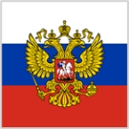**President

Head of Sate of the Russian Federation and Commander-in- Chief of all Russian Armed Forces in Times of war.

1. 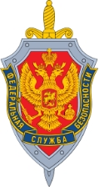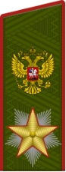FSB (former KGB) Chairman

Head of Foreign and Domestic Intelligence

1. Army Marshal

Senior Commander and Adviser on all military affairs

1. 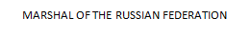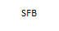Foreign Minister

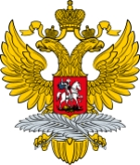Head of Foreign Affairs. Communicates with his /her counterparts with other Foreign Affairs Ministers based on foreign policy decisions of the Russian Federation President

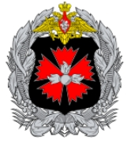

1. GRU General

Head of the Military Intelligence of the Russian Federation

1. 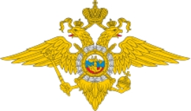Interior Minister

Head of the Military and Intelligence Units in the protection of the Russian Federation against internal and external threats

1. 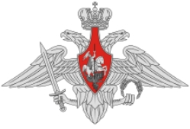Defense Minister

Head of the National Defense. Closest Adviser of the President on all military plans, tactical or strategic.

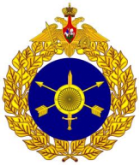

1. General - Strategic Rocket Forces

Reports to the Air Marshall. Advises the President on the use and release and launch of all nuclear ballistic missile.

1. 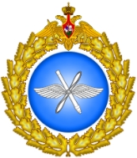Air Marshall

Head of all Russian Federation Air Force Assets. In command too of all strategic rocket forces

1. Admiral

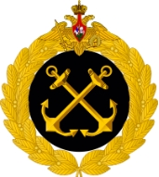Head of the Russian Federation Navy. Advise the President on all aspects of Naval warfare

1. 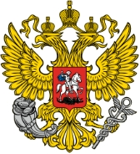Economic Minister

In-Charge of the Russian Federation economy, formulation of the national budget, control of finances, and all industries including agriculture

1. Political Adviser

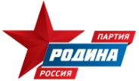Chief Political Adviser and closest ally of the Russian Federation President.

**VII ROLES**

**BLUE TEAM**

1. ****President of the United States (POTUS)

Chief Executive Decision-maker based on the best advice of the NSC members with the objective of meeting the strategic plans of the US and protection/ ll be the preservation of its vital national & global interests.

1. V-POTUS

Shall be the successor of Potus in cases of incapacity or the invocation ot the 25th amendment which is the removal of Potus based on the unanimous vote/signatures of the cabinet and the Vice-Potus. He/she is the adviser to the Potus when only sought. During a national emergency crisis, the Vice-Potus is transferred to a different, safe and undisclosed location to ensure continuity of government should the Potus be incapacitated.

1. 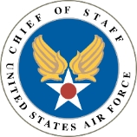Chief of Staff

Is the closest political adviser to the Potus. Sometimes referred to as the “Little President”. He/she more often than not, is the executor of the Potus’ executive decisions.

1. National Security Adviser

Advises the POTUS on all National Security Matters. Recipient and coordinator of intelligence and information coming from CIA, DOD (Department of Defense), NSA (National Security Agency), FBI, etc.

1. CIA Director

Head of Central Intelligence; has control of HUMINT (Human Intelligence), SIGINT (Signals Intelligence, ELINT (Electronic Intelligence) and the NRO (National Reconnaissance Office) which is in charge of global Recon Satellites of the US that is in geosynchronous orbit with earth. Provides all necessary information and intelligence to POTUS and analysis of threats and intentions including movements of resources, if any, by the other countries.

1. Chairman- Joint Chiefs of Staff

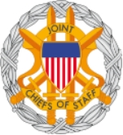Heads all the branches of the US Armed Forces which are, the army, marines, navy, air force, and coast guard. Advises the POTUS on the best course of Action, defensively or offensively on all military matters based on the strategic objective of the US.

In this exercise, the Chairman is a Navy Admiral.

1. Secretary of State

Head of the State Department who represents and executes the foreign policy of the POTUS. A close adviser of the POTUS on geo-political matters. For the simulation exercise: Records all executive decisions of the POTUS and sends communiqué (Communication) to his counterpart in RUSSIAN, the Foreign Minister to relay the message and/or conditions of the POTUS.

1. 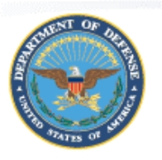Secretary of Defense

Civilian Head of the US Military establishment. Represents POTUS on the defense policies of the US. A close adviser of the POTUS on National Security Matters.

1. 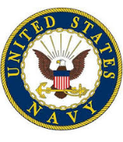Chief of Naval Operations

Head of the US Navy Advises the POTUS on all aspects Naval Warfare.

1. Air Force General

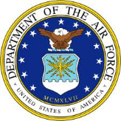Head of all the air force including: SAC (Strategic Air Command), TAC (Tactical Air Command), AAC (Air force Airlift Command), Drone Operations and the Land-based ballistic missile regiments. Advises the POTUS on all air warfare including the use of the nuclear ballistic missiles and nuclear bombers.

1. FEMA Director

Over-all In-Charge of ALL Federal Government Agencies in times of national emergencies and disaster response.

Coordinates with the Department of Defense, hospitals, medical aid workers , the Center for Disease Control and other municipal, state and federal offices agencies to immediately respond to natural calamities and disasters, pandemic outbreaks and victims of terror attacks.

Center for Disease Control Chairman . Over-All In-Charge in the control and coordination of the federal government response to pandemic outbreaks, viral attacks, prevent the spread of infectious diseases and terror attacks involving biochemical and other weapons of mass destruction.

1. FBI Director

Head of the [Federal Bureau of Investigation](https://en.wikipedia.org/wiki/Federal_Bureau_of_Investigation), the United States' primary federal [law enforcement agency](https://en.wikipedia.org/wiki/Law_enforcement_agency), and is responsible for its day-to-day operations.

The Director briefs the President on any issues that arise from within the FBI and in an additional capacity to the [Director of National Intelligence](https://en.wikipedia.org/wiki/Director_of_National_Intelligence), as the FBI is also part of the [United States Intelligence Community](https://en.wikipedia.org/wiki/United_States_Intelligence_Community).

**VII ROLES**

**YELLOW TEAM**

**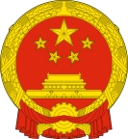**

1. Premiere

Head of the PROC “Anquan Bou” Communist Party.

1. Vice Premier

Shall be the successor Premiere in cases of incapacity. He/she is the adviser to the Premiere when only sought. During a national emergency crisis, the Vice-Premier is transferred to a different, safe and undisclosed location to ensure continuity of government should the Premier be incapacitated.

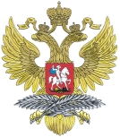

1. Foreign Minister

Head of Foreign Affairs. Communicates with his / her counterpart Secretary of State based on Foreign Policy decisions of the Premiere.

1. 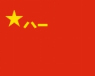PLA Army Marshal

Senior adviser on all military affairs; In charge of the army, the fleets and air force.

1. 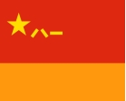PLA Strategic Rocket Forces

Controls the nation's arsenal of land-based [ballistic missiles](https://en.wikipedia.org/wiki/Ballistic_missile) - both nuclear and conventional.

1. PLA Navy Admiral

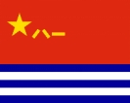

Head of the Navy. Advises the premier on all Naval Warfare aspects. PROC Ministry of State Security

1. PROC Ministry of State Security

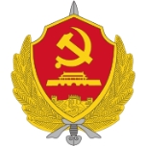

Ensures the security of the state through effective measures against enemy agents, spies, and counter-revolutionary activities designed to sabotage or overthrow China's socialist system.

1. 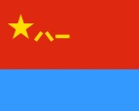PLA Air Force

Head of all the Air Force. In command of all strategic rocket forces (Nuclear Ballistic Missiles)

1. 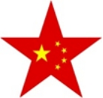PROC Commisar

In-Charge of the building of Party organizations and political ideology, and manage the employment forces' building.

1. PROC Military Intelligence

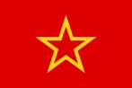

Head of the Foreign and Domestic Intelligence

1. PROC Economic Minister



Head of the PROC Economy. Controls all industries and advises the premiere on all matters to make the Chinese Economy defeat other Superpowers.

1. PROC Chief Political Adviser

Chief and closest political adviser of the premiere particularly on domestic and international affairs.

**VII ROLES**

**GREEN TEAM**

1. ****President

Chief Executive and Head of State. Final Decision of government regarding domestic and foreign policy rests in his position.

1. Vice President

The second highest ranking government Indian official. Succesor of the President if incapacitated. Closest advisor to the President.

1. Prime Minister

Head of the Parliament and the cabinet. Advises the President on domestic and foreign policy. Third in line of succession.

1. 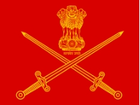General of the Indian Army

Commanding General of the Indian Army. Advises the President on all military actions, whether conventional or nuclear warfare.

1. 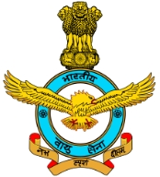Air Marshal of the Indian Air Force

Commanding General of the Indian Air Forces, Over-All Commander of nuclear missiles and bombs in the Indian arsenal.

1. Vice Admiral of the Indian Navy

Commander of all Indian navy assets. Advises the President on all aspect of Naval warfare.

1. 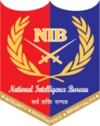Chairman of the Intelligence Bureau

Head of foreign and domestic intelligence gathering and analysis. Advises the President on all threats and intentions of India’s adversaries.

1. 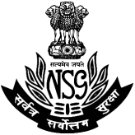National Security Adviser

Advises the President on all foreign and domestic security matters and courses of action the Indian Government should take to protect its interests.

1. Foreign Minister of State

Head of foreign policy and represents the President on all diplomatic matters. Commnicate with other countries the position taken by the Indian Government.

1. Directorate of Military Intelligence

Head of all military intelligence. Advises the commanders of the Indian Armed Forces and the President on the capabilities and resources of their adversaries.

1. 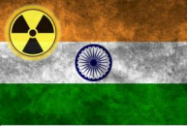Nuclear Command Authority Adviser

Close Adviser of the President on all matters governing the release of nuclear weapons.

1. Adviser for Political Affairs

Political Advisor of the President concerning foreign and domestic policies.

**VII ROLES**

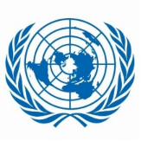

**UNITED NATIONS**

**United Nations Secretary-General**

Under the Charter, the Secretary-General is appointed by the General Assembly upon the recommendation of the Security Council. Equal parts diplomat and advocate, civil servant and CEO, the Secretary-General is a symbol of United Nations ideals and a spokesman for the interests of the world's peoples, in particular the poor and vulnerable among them.

The Charter describes the Secretary-General as "chief administrative officer" of the Organization, who shall act in that capacity and perform "such other functions as are entrusted" to him or her by the Security Council, General Assembly, Economic and Social Council and other United Nations organs. The Charter also empowers the Secretary-General to "bring to the attention of the Security Council any matter which in his opinion may threaten the maintenance of international peace and security". These guidelines both define the powers of the office and grant it considerable scope for action. The Secretary-General would fail if he did not take careful account of the concerns of Member States, but he must also uphold the values and moral authority of the United Nations, and speak and act for peace, even at the risk, from time to time, of challenging or disagreeing with those same Member States.

**Deputy Secretary General**

Second Ranking Officer of the UN and assists the Secretary General of the UN in fulfilling the UN Mandate.

**Chairman UN Security Council**

The Security Council mostly composed of permanent members of Superpower countries is mandated to ensure global peace and enforce sanction against erring nations.

It is also mandated to assist in the conduct of a peaceful settlement through negotiations by warring countries.

**VIII CAPABILITIES**

**RED TEAM**

**RUSSIAN AIRCRAFT**

|  |  |
| --- | --- |
| Foxhounds | Can beat all US aircraft except Raptor, Lightning, Superhornet and Eagles |
| Foxbats | Can beat all US aircraft except Raptor, Lightning, Superhornet and Eagles |
| Flankers | Can beat all US aircraft except Raptor and Lightning; Equal to Eagles |
| Fulcrums | Can beat all US aircraft except Raptor, Lightning, Eagles; Equal to Falcons and Hornets |
| Fencers | Can beat all US aircraft except Raptor, Lightning, Hornet, Superhornet and Eagles  Can evade electronic warfare defenses and launch 8 conventional radar-guided anti-ship missiles |
| Backfire | Can evade all air defense and all a/c except Raptor, Lightning, Hornet, Superhornet and Eagles  Can deliver payload to target thru supersonic speed  Can carry 4 nuclear tipped missiles code name “Kitchen” |
| Badgers | Can evade air defense except all US fighter aircraft.  Can deliver payload thru sub-sonic speed; Can carry 4 nuclear  tipped missiles code name “Kitchen”. |
| Bear | Naval Recon plane can be shot down by all US fighter aircraft |
| Mainstay | Early warning radar plane (land or sea) can be shot down by all  US fighter air crafts |
| PAK FA SU 57 | 5th Generation Russian Air Superiority Fighter |

**RUSSIAN SHIPS**

|  |  |
| --- | --- |
| RUSSIAN Carrier Strike Group | * cannot defeat US CVSG but can destroy US A.G./T.F. * A US SSN can damage a Russian CVBG. A US SSBN can destroy this group * if it can launch & target the precise location   Basic Composition of a RUSSIAN CVBG  1 aircraft carrier  1 battle cruiser  4 guided cruiser  2 guided destroyer  2 guided frigates  1 SSN |
| Amphibious Groups | * An invasion task force pre-positioned composed of between 30-100 ships depending on mission * An A.G. can be attacked, damaged, destroyed by US Airforce bombers, SSNs or by an American CVBG.   Basic Composition of Russian A.G.    2 Battle Cruisers  10 LSTs (Tank Carriers)  10 LHA (Red Army Carrier)  2 LSDs (Floating Docks)  2 Replenishment Ships  2 Auxiliary Ships  5 Guided Cruisers  5 Guided Destroyers  7 Guided Frigates.  2 SSNs  1 SSGN |
| Russian Subs | All SSBNs, SSNs & SSGNs can be destroyed by ASW (Anti-Submarine Warfare) Ships, planes and other subs when discovered.   * SSGN – Kilo Class   - Can launch sub to surface ASM (Anti ship Missiles) conventional or nuclear-tipped against a US CVSG or US A/G. It has 30 ASMs.   * SSBN – Typhoon Class   - A ballistic missile submarine that has 20 missile at 4 MIRVs (Multiple-Independent Re-entry Vehicle) with warhead/vehicle. Yield of 200 KT each. Missile’s NATO code name is “Sturgeon”.   * SSBN – Borei Class   - A ballistic missile submarine capable of carrying 16 missiles with 4 MIRVs at 150 KT/Warhead  **ICBM** (Intercontinental Ballistic Missile)  Code name “Satan II”   * 1. Located under hardened bunker silos with 8 MIRVS warhead and a yield of 750KT nuclear bomb.   2. 1 regiment of SS is equivalent to 30 silos     **RT-2PM TOPOL**  SS-25 : Code name “Sickle”  Medium ranged ballistic missile usually carried by a TEL (Tractor-Erector – Launcher) that has a single warhead nuclear with a yield of 800 KT. The TELs are highly mobile and based in Central and Eastern Planned Europe. Planned deployments are in southern Russia targeting Central Asia, Middle East and China |
| TU – 95 Bear / Foxtrot | * ASW Propeller driven aircraft with 8 AT-U torpedoes (Land Based; Long-Ranged) * Can also carry nuclear depth chares from 10-15KT * Can sink all types of Submarines * Can carry 80 sonobouys for detection of submarines underwater through passive and active sonar * Carries (MAD) Magnetic anomaly detector to detect unusual magnetic activity or earth’s subsurface created by a Sub |
| ILYUSIN 38 “May” | * ASW Propeller Driven Aircraft with 8 AT-U Torpedoes   (Land Based)   * Can sink all types of submarine underwater * Can carry nuclear depth charges from 10-15 KT * Can carry 50 Sonobouys for submarine detection through passive and active sonar * Short range |
| RUSSIAN Carrier | * Kuznetsov Class * 4,300 Crew * 60 Aircraft fixed & rotary   12 Flanker D (Air defense)  34 Fulcrums (Attack)  14 Helix Choppers (ASW)   * Point Defense   CIWS (Close-in Weapons System) – 5 in gun |

**RUSSIAN MILITARY CAPABILITIES**

|  |  |  |
| --- | --- | --- |
| **AIRCRAFT CARRIER** | | |
| **CLASS** | **NAME** | **PICTURE** |
| **KUZNETSOV** | **Admiral Flota Sovetskogo Soyuza Kuznetsov** |  |
| **BATTLECRUISERS** | | |
| **KIROV** | **Admiral Nakhimov/ KALININ** |  |
|  | **Pyotr Velikiy OR YURI ANDROPOV** |  |
|  | **ADMIRAL LAZAREV FRUNZE** |  |
|  | **Admiral Ushakov** |  |
| **DESTROYERS (15)** | | |
| **UDALOY** | **Vice-Admiral Kulakov** |  |
|  | **Marshal Shaposhnikov** |  |
|  | **Admiral Tributs** |  |
|  | **Severomorsk** |  |
|  | **Admiral Vinogradov** |  |
|  | **Admiral Levchenko** |  |
|  | **Admiral Panteleyev** |  |
|  | **Admiral Chabanenko** |  |
| **SOVREMENNY** | **Nastoychivyy** |  |
|  | **Admiral Ushakov** |  |
| **GUIDED CRUISERS** | | |
| **SLAVA** | **Marshal Ustinov** |  |
|  | **Varyag** |  |
|  | **MOSKVA** |  |
| **FRIGATES (11)** | | |
| **KRIVAK** | **Ladny** |  |
|  | **Pytlivyy** |  |
| **Neustrashimyy** | **Neustrashimyy** |  |
|  | **Yaroslav Mudry** |  |
| **Admiral Grigorovich** | **Admiral Grigorovich** |  |
|  | **Admiral Essen** |  |
|  | **Admiral Makarov** |  |
| **Gepard** | **Tatarstan** |  |
|  | **Dagestan** |  |
| **Admiral Gorshkov** | **Admiral Flota Sovetskogo Soyuza Gorshkov** |  |
|  | **Admiral Flota Kasatonov** |  |
| **SUBMARINES (SSBN)** | | |
| **Typhoon** | **Dmitriy Donskoy** |  |
| **Borei** | **Yuriy Dolgorukiy** |  |
|  | **Aleksandr Nevskiy** |  |
|  | **Vladimir Monomakh** |  |
|  | **Knyaz Vladimir** |  |
|  | **Knyaz Oleg** |  |
| **SUBMARINES (SSGN)** | | |
| **Oscar II** | **Irkutsk** |  |
|  | **Chelyabinsk** |  |
|  | **Smolensk** |  |
|  | **Orel** |  |
|  | **Tver** |  |
|  | **Omsk** |  |
|  | **Tomsk** |  |
| **Yasen (charlie?)** | **Severodvinsk** |  |
|  | **Kazan** |  |
|  | **Novosibirsk** |  |
| **KILO** | **Nurlat** |  |
|  | **Ust'-Kamchatsk** |  |
|  | **Vladikavkaz** |  |
|  | **Magnitogorsk** |  |
|  | **Ust´-Bolsheretsk** |  |
|  | **Lipetsk** |  |
|  | **Komsomolsk-na-Amure** |  |
|  | **Krasnokamensk** |  |
|  | **Dmitrov** |  |
|  | **Kaluga** |  |
|  | **Alrosa** |  |
| **IMPROVED KILO** | **Novorossiysk** |  |
|  | **Rostov na Donu** |  |
|  | **Staryy Oskol** |  |
|  | **Krasnodar** |  |
|  | **Velikiy Novgorod** |  |
|  | **Kolpino** |  |
|  | **Petropavlovsk-Kamchatsky** |  |
|  | **Volkhov** |  |
|  | **Magadan** |  |
| **CHARLIE I** | **K-25** |  |
|  | **K-43** |  |
|  | **K-121** |  |
|  | **K-201** |  |
|  | **K-212** |  |
|  | **K-302** |  |
|  | **K-308** |
|  | **K-313** |
|  | **K-320** |
|  | **K-325** |
|  | **K-429** |
| **CHARLIE II** | **K-209** |  |
|  | **K-452** |
|  | **K-458** |
|  | **K-479** |
|  | **K-503** |
|  | **K-508** |
| **SUBMARINES (SSN)** | | |
| **Alfa Class** | **K-64** |  |
|  | **K-123** |
|  | **K-316** |
|  | **K-373** |
|  | **K-432** |
|  | **K-463** |
|  | **K-493** |
| **SIERRA CLASS** | **Carp** |  |
|  | **Kostroma** |  |
|  | **Nizhniy Novgorod** |  |
|  | **Pskov** |  |
| **VICTOR** | **Yorsh** |  |
|  | **Syomga** |  |
|  | **Shchuka** |  |
| **AKULA** | **Akula** |  |
|  | **Ak Bars** |  |
|  | **Barnaul** |  |
|  | **Kashalot** |  |
|  | **Pantera** |  |
|  | **Volk** |  |
|  | **Bratsk** |  |
|  | **Leopard** |  |
|  | **Tigr** |  |
|  | **Magadan** |  |
|  | **Vepr** |  |
|  | **Kuzbass** |  |
|  | **Gepard** |  |
|  | **Kuguar** |  |
|  | **Samara** |  |
|  | **Nerpa** |  |
|  | **Iribis** |  |
| **LANDING SHIPS / LST** | | |
| **Tapir Class**  Alligator | **Orsk** |  |
|  | **Nikolay Vilkov** |  |
|  | **Nikolay Filchenkov** |  |
| **Project 23900** | **Ivan Rogov** |  |
|  | **Mitrofan Moskalenko** |
| **LANDING CRAFT AIR CUSHION** | | |
| **Kalmar Class** | 533 |  |
|  | 639 |
|  | 640 |
| **Aist Class** | #609 |  |
|  | #610 |
|  | #615 |
|  | #700 |
|  | MDK 89 (formerly #730) |
|  | MDK 113 (formerly #722) |
| **Tsaplya Class** |  |  |
| **Zubr** | Evgeniy Kocheshkov |  |
|  | Mordoviya |
| **AIRCRAFT** | | |
|  | **SUKHOI SU – 27**  **NATO DESIGNATION:**  **FLANKER** |  |
|  | **SU-30**  **NATO DESIGNATION:**  **Flanker-C/G/H** |  |
|  | **SU-33**  **NATO DESIGNATION:**  **FLANKER-D** |  |
|  | **MiG 29**  **NATO DESIGNATION:**  **FULCRUM** |  |
| **PAKFA** | **SU-57**  **NATO DESIGNATION:**  **FELON** |  |
| **BACKFIRE** | **TU 22**  **NATO DESIGNATION:**  **BLINDER** |  |
|  | **TU-16**  **NATO DESIGNATION:**  **BADGER** |  |
|  | **TU-95**  **NATO DESIGNATION:**  **BEAR** |  |
| **ILYUSHIN** | **ILYUSHIN 76**  **NATO DESIGNATION:**  **Candid** |  |
|  | **SU-24**  **NATO DESIGNATION:**  **FENCER** |  |
|  | **MiG 21**  **NATO DESIGNATION:**  **FISHBED** |  |
|  | **SU 20 / 21 / 17**  **NATO DESIGNATION:**  **FITTER** |  |
|  | **ILYUSHIN II-80**  **NATO DESIGNATION:**  **MAXDOME** |  |
|  | **Beriev A-50 (40)**  **NATO DESIGNATION:**  **Mainstay** |  |
|  | **Mikoyan-Gurevich MiG-25**  **NATO DESIGNATION:**  **FOXBAT** |  |
|  | **Mikoyan MiG-31**  **NATO DESIGNATION: FOXHOUND** |  |
|  | **Mil Mi-24**  **NATO DESIGNATION: HIND** |  |
|  | **Mil Mi-17**  **NATO DESIGNATION:**  **HIP** |  |
|  |  |  |
| **MISSILES** | | |
|  | **RT-2PM2 TOPOL-M**  **NATO DESIGNATION : SS27 SICKLE B**  **Nuclear**  **Yield: 500kt** |  |
|  | **RT-2PM TOPOL**  **SS25**  **NATO DESIGNATION:**  **SICKLE**  **Nuclear**  **Yield: 800kt** |  |
|  | **R 36 (SS 18) Sarmat**  **NATO DESIGNATION:**  **Nuclear**  **SATAN II**  **Yield: 750kt** |  |

**NUCLEAR AIR DEFENSE SYSTEM**

Dead Hand ([Russian](https://en.wikipedia.org/wiki/Russian_language): Система «Периметр», *Systema "Perimetr"*, lit. "Perimeter" System, with the [GRAU](https://en.wikipedia.org/wiki/GRAU) Index 15E601, [Cyrillic](https://en.wikipedia.org/wiki/Cyrillic_script): 15Э601), also known as Perimeter, is a [Cold War](https://en.wikipedia.org/wiki/Cold_War)-era automatic [nuclear weapons](https://en.wikipedia.org/wiki/Nuclear_weapon)-control system (similar in concept to the American [AN/DRC-8 Emergency Rocket Communications System](https://en.wikipedia.org/wiki/AN/DRC-8_Emergency_Rocket_Communications_System)) that was constructed by the [Soviet Union](https://en.wikipedia.org/wiki/Soviet_Union). The system remains in use in the post-Soviet [Russian Federation](https://en.wikipedia.org/wiki/Russia). An example of [fail-deadly](https://en.wikipedia.org/wiki/Fail-deadly) and [mutual assured destruction](https://en.wikipedia.org/wiki/Mutual_assured_destruction) deterrence, it can automatically initiate the launch of the Russian [intercontinental ballistic missiles](https://en.wikipedia.org/wiki/Intercontinental_ballistic_missile) (ICBMs) by sending a pre-entered highest-authority order from the [General Staff of the Armed Forces](https://en.wikipedia.org/wiki/General_Staff_of_the_Armed_Forces_of_the_Russian_Federation), Strategic Missile Force Management to command posts and individual silos if a nuclear strike is detected by seismic, light, radioactivity, and pressure sensors even with the commanding elements fully destroyed. By most accounts, it is normally switched off and is supposed to be activated during times of crisis; however, as of 2009, it was said to remain fully functional and able to serve its purpose when needed.

**VIII CAPABILITIES**

**BLUE TEAM**

**US AIRCRAFT**

|  |  |
| --- | --- |
| F-35 “Lightning” | Can beat all Russian aircraft |
| F-22 “Raptor” | Can beat all Russian aircraft |
| F-18E/F “Superhornet” | Can beat all Russian aircraft except PAK FA |
| F-15 “Eagle” | Can beat all Russian aircraft except equal to “Flankers” |
| F-15E “Strike Eagle” | Can beat all Russian aircraft except equal to “Flankers” |
| F-16 “Falcon” | Can beat all other Russian aircraft except :   * Foxhounds * Foxbats * Flankers   And equal to Fulcrums |
| F-18 “Hornets” | 1. Can beat all other aircraft except “Foxhounds” ; 2. Equal to “Flankers”, “Fulcrums” and “Foxbats” |
| E2C “ Hawkeye” And E3B “Sentry” | Recon Aircraft can be shot down by all Russian fighter aircraft |
| B-1B | Can penetrate air defenses and intercept aircraft and deliver its nuclear payload to its target. This is a Third-strike option |
| B-52 | Can be shot down by fighter aircraft but can evade other air defenses to deliver its nuclear payload to its designated target |
| B-2 Spirit | Stealth Bomber low flying and undetectable to most radars |

**US SHIPS**

|  |  |
| --- | --- |
| Aircraft Carrier Battle Groups | * can defeat all Russian and Chinese battle groups but can be damaged or defeated by Russian and Chinese aviation bombers such as Fencers, Badgers, and/or Backfires. * Aircraft Carrier can be damaged **or** sunk by Russian SSGNs or SSNs. * A carrier battle group is basically composed of the ff:   1 – Aircraft carrier  2 – Guided Missile Cruisers  2 – Guided Missile Destroyers  2 – Guided Missile Frigates  1 – Replenishment Ship  2 – SSNs |
| Amphibious/ Surface Groups | * An invasion and pre-positioned task force of at least 30-100 ships depending on mission. It is vulnerable and can be damaged, sunk and/or totally defeated by Soviet Naval Aviation Bombers such as Fencers, Badgers, or Backfires. Can be attacked by SSNs and SSGNs. * Total and Immediate defeat of an amphibious group is if a Russian SSBN can launch and target the precise location of the A.G. * Basic Amphibious Group Task Force is composed of :   4 LHAs (Marine Carriers)  4 LST (Tank Carriers)  2 LSDs (Floating Docks)  10 Auxilliary Ships  10 Replenishment Ships  6 Guided Cruisers  6 Guided Destroyers  6 Guided Frigates  2 SSNss |
| US Aircraft Carrier “ Nimitz or Ford Group” | - 6,000 crew  - 90 fixed & rotary wing aircraft  24 Superhornets F18-E  24 Superhornets F18-F  24 Hornets  4 Hawkeye  4 Seaking Helicopters (ASW/SAR)  4 Vikings (ASW)  Point Defense :  - Medium Range Sparrows  - CIWS (Close-in Weapons System)  - Gatling Gun 3,000 RDS/Sec |
| US – Guided Cruisers – Ticonderoga Class | * 60 Tomahawk (SSM) Nuclear / Conventional   124 S-MR (Standard SAM-Medium Range)  16 Harpoon (ASM)   * Guided Destroyer (Spruance or Arleigh Burke Class)   36 Tomahawk (SSM) Nuclear / Conventional  200 S-MR (SAM) Medium Range  16 Harpoon (ASM)  8 Torpedoes (ADCAP) for ASW |
| Littoral Combat Ship | ASW Capable. Light AA Defense Capability |

**US SUBS**

|  |  |
| --- | --- |
| SSBNs, SSNs & SSGNs | can be damaged or sunk by ASW (Anti-Submarine Warfare), ships, planes or other subs when discovered)   * NUCLEAR MISSILEs   **ICBMs** (Intercontinental Ballistic Missile)   * Minuteman II   + - * 10 MIRVS (Multiple Independent Re-entry Vehicle)       * 1 Vehicle is equal to warhead       * 1 Warhead is capable of 500KT Bombs Yield     **SLBMs** (Submarine Launched Ballistic Missile)   * Trident II   10 MIRVS - 1 Warhead is capable up to 150 KT to 350KT Bombs Yield  **AGM (**Air Guided Missiles)   * Tomahawk Cruise Missile that can be delivered by B-2 or B-52’s * Can be conventional or nuclear – tipped * Warhead has yield of 100KT to 300 KT Bombs * B-52s : Can carry 8 Cruise Missiles * B-1B : Can carry 16 Cruise Missiles * B-2 Spirit * Ohio – Class SSBNs : Can carry 24 SLBMs * 1 Regiment of ICBMs is equivalent to 50 ICBM silos. |

**LAND-BASED**

|  |  |
| --- | --- |
| P-3C-ORION | * Can also carry nuclear depth chares from 10-15KT * Can sink all types of Submarines * Can carry 80 sonobouys for detection of submarines underwater through passive and active sonar * Carries (MAD) Magnetic anomaly detector to detect unusual magnetic activity or earth’s subsurface created by a Sub |
| S-3B-Viking | * Aircraft carrier – based ASW jet plane carries 8 MK-II Torpedoes * Can sink all types of submarine underwater * Can carry nuclear depth charges from 10-15 KT * Can carry 50 Sonobouys for submarine detection through passive and active sonar * Short range |

**US MILITARY CAPABILITIES**

|  |  |  |
| --- | --- | --- |
| **AIRCRAFT CARRIER (11)** | | |
| CLASS | NAME | PICTURE |
| **Gerald R. Ford** | USS Gerald R. Ford (CVN-78) |  |
| **Nimitz** | USS Nimitz (CVN-68)  USS Dwight D. Eisenhower (CVN-69)  USS Carl Vinson (CVN-70)  USS Theodore Roosevelt (CVN-71)  USS Abraham Lincoln (CVN-72)  USS George Washington (CVN-73)  USS John C. Stennis (CVN-74)  USS Harry S. Truman (CVN-75)  USS Ronald Reagan (CVN-76)  USS George H.W. Bush (CVN-77) |  |
| **Amphibious Assault Ships (9)** | | |
| **Wasp** | USS Wasp (LHD-1)  USS Essex (LHD-2)  USS Kearsarge (LHD-3)  USS Boxer (LHD-4)  USS Bataan (LHD-5)  USS Iwo Jima (LHD-7)  USS Makin Island (LHD-8) |  |
| **America** | USS America (LHA-6)  USS Tripoli (LHA-7) |  |
| **Amphibious Command Ships (2)** | | |
| **Blue Ridge** | USS Blue Ridge (LCC-19)  USS Mount Whitney (LCC-20) |  |
| **Amphibious transport docks (12)** | | |
| **San Antonio** | USS San Antonio (LPD-17)  USS New Orleans (LPD-18)  USS Mesa Verde (LPD-19)  USS Green Bay (LPD-20)  USS New York (LPD-21)  USS San Diego (LPD-22)  USS Anchorage (LPD-23)  USS Arlington (LPD-24)  USS Somerset (LPD-25)  USS John P. Murtha (LPD-26)  USS Portland (LPD-27)  USS Fort Lauderdale (LPD-28) |  |
| **Dock landing ships (10)** | | |
| **Harpers Ferry** | USS Harpers Ferry (LSD-49)  USS Carter Hall (LSD-50)  USS Oak Hill (LSD-51)  USS Pearl Harbor (LSD-52) |  |
| **Whidbey Island** | USS Germantown (LSD-42)  USS Gunston Hall (LSD-44)  USS Comstock (LSD-45)  USS Tortuga (LSD-46)  USS Rushmore (LSD-47)  USS Ashland (LSD-48) |  |
| **Cruisers (22)** | | |
| **Ticonderoga** | USS Bunker Hill (CG-52)  USS Mobile Bay (CG-53)  USS Antietam (CG-54)  USS Leyte Gulf (CG-55)  USS San Jacinto (CG-56)  USS Philippine Sea (CG-58)  USS Princeton (CG-59)  USS Normandy (CG-60)  USS Monterey (CG-61)  USS Chancellorsville (CG-62)  USS Cowpens (CG-63)  USS Gettysburg (CG-64)  USS Chosin (CG-65)  USS Hue City (CG-66)  USS Shiloh (CG-67)  USS Anzio (CG-68)  USS Vicksburg (CG-69)  USS Lake Erie (CG-70)  USS Cape St. George (CG-71)  USS Port Royal (CG-73) |  |
| **Destroyers (72)** | | |
| **Arleigh Burke** | USS Arleigh Burke (DDG-51)  USS Barry (DDG-52)  USS John Paul Jones (DDG-53)  USS Curtis Wilbur (DDG-54)  USS Stout (DDG-55)  USS John S. McCain (DDG-56)  USS Mitscher (DDG-57)  USS Laboon (DDG-58)  USS Russell (DDG-59)  USS Paul Hamilton (DDG-60)  USS Ramage (DDG-61)  USS Fitzgerald (DDG-62)  USS Stethem (DDG-63)  USS Carney (DDG-64)  USS Benfold (DDG-65)  USS Gonzalez (DDG-66)  USS Cole (DDG-67)  USS The Sullivans (DDG-68)  USS Milius (DDG-69)  USS Hopper (DDG-70)  USS Ross (DDG-71)  USS Mahan (DDG-72)  USS Decatur (DDG-73)  USS McFaul (DDG-74)  USS Donald Cook (DDG-75)  USS Higgins (DDG-76)  USS O'Kane (DDG-77)  USS Porter (DDG-78)  USS Oscar Austin (DDG-79)  USS Roosevelt (DDG-80)  USS Winston S. Churchill (DDG-81)  USS Lassen (DDG-82)  USS Howard (DDG-83)  USS Bulkeley (DDG-84)  USS McCampbell (DDG-85)  USS Shoup (DDG-86)  USS Mason (DDG-87)  USS Preble (DDG-88)  USS Mustin (DDG-89)  USS Chafee (DDG-90)  USS Pinckney (DDG-91)  USS Momsen (DDG-92)  USS Chung-Hoon (DDG-93)  USS Nitze (DDG-94)  USS James E. Williams (DDG-95)  USS Bainbridge (DDG-96)  USS Halsey (DDG-97)  USS Forrest Sherman (DDG-98)  USS Farragut (DDG-99)  USS Kidd (DDG-100)  USS Gridley (DDG-101)  USS Sampson (DDG-102)  USS Truxtun (DDG-103)  USS Sterett (DDG-104)  USS Dewey (DDG-105)  USS Stockdale (DDG-106)  USS Gravely (DDG-107)  USS Wayne E. Meyer (DDG-108)  USS Jason Dunham (DDG-109)  USS William P. Lawrence (DDG-110)  USS Spruance (DDG-111)  USS Michael Murphy (DDG-112)  USS John Finn (DDG-113)  USS Ralph Johnson (DDG-114)  USS Rafael Peralta (DDG-115)  USS Thomas Hudner (DDG-116)  USS Paul Ignatius (DDG-117)  USS Daniel Inouye (DDG-118)  USS Delbert D. Black (DDG-119)  USS Frank E. Petersen Jr. (DDG-121) |  |
| **Zumwalt** | USS Zumwalt (DDG-1000)  USS Michael Monsoor (DDG-1001) |  |
| **Littoral combat ships (22)** | | |
| **Freedom** | USS Fort Worth (LCS-3)  USS Milwaukee (LCS-5)  USS Detroit (LCS-7)  USS Little Rock (LCS-9)  USS Sioux City (LCS-11)  USS Wichita (LCS-13)  USS Billings (LCS-15)  USS Indianapolis (LCS-17)  USS St. Louis (LCS-19)  USS Minneapolis-Saint Paul (LCS-21) |  |
| **Independence** | USS Coronado (LCS-4)  USS Jackson (LCS-6)  USS Montgomery (LCS-8)  USS Gabrielle Giffords (LCS-10)  USS Omaha (LCS-12)  USS Manchester (LCS-14)  USS Tulsa (LCS-16)  USS Charleston (LCS-18)  USS Cincinnati (LCS-20)  USS Kansas City (LCS-22)  USS Oakland (LCS-24)  USS Mobile (LCS-26)  USS Savannah (LCS-28) |  |
| **Mine countermeasure ships (8)** | | |
| **Avenger** | USS Sentry (MCM-3)  USS Devastator (MCM-6)  USS Patriot (MCM-7)  USS Pioneer (MCM-9)  USS Warrior (MCM-10)  USS Gladiator (MCM-11)  USS Dextrous (MCM-13)  USS Chief (MCM-14) |  |
| **Coastal patrol ships (5)** | | |
| **Cyclone** | USS Hurricane (PC-3)  USS Monsoon (PC-4)  USS Sirocco (PC-6)  USS Chinook (PC-9)  USS Thunderbolt (PC-12) |  |
| **Submarine Tender (2)** | | |
| **Emory S. Land** | USS Emory S. Land (AS-39)  USS Frank Cable (AS-40) |  |
| **FRIGATES (1)** | | |
| **Classic Frigate** | USS Constitution |  |
| **Submarines** | | |
| **Missile (ballistic) (14)** | | |
| **Ohio** | USS Henry M. Jackson (SSBN-730)  USS Alabama (SSBN-731)  USS Alaska (SSBN-732)  USS Nevada (SSBN-733)  USS Tennessee (SSBN-734)  USS Pennsylvania (SSBN-735)  USS West Virginia (SSBN-736)  USS Kentucky (SSBN-737)  USS Maryland (SSBN-738)  USS Nebraska (SSBN-739)  USS Rhode Island (SSBN-740)  USS Maine (SSBN-741)  USS Wyoming (SSBN-742)  USS Louisiana (SSBN-743) |  |
| **Missile (guided) (4)** | | |
| **Ohio** | USS Ohio (SSGN-726)  USS Michigan (SSGN-727)  USS Florida (SSGN-728)  USS Georgia (SSGN-729) |  |
| **Attack (50)** | | |
| **Los Angeles** | USS Providence (SSN-719)  USS Chicago (SSN-721)  USS Key West (SSN-722)  USS Oklahoma City (SSN-723)  USS Helena (SSN-725)  USS Newport News (SSN-750)  USS San Juan (SSN-751)  USS Pasadena (SSN-752)  USS Albany (SSN-753)  USS Topeka (SSN-754)  USS Scranton (SSN-756)  USS Alexandria (SSN-757)  USS Asheville (SSN-758)  USS Jefferson City (SSN-759)  USS Annapolis (SSN-760)  USS Springfield (SSN-761)  USS Columbus (SSN-762)  USS Santa Fe (SSN-763)  USS Boise (SSN-764)  USS Montpelier (SSN-765)  USS Charlotte (SSN-766)  USS Hampton (SSN-767)  USS Hartford (SSN-768)  USS Toledo (SSN-769)  USS Tucson (SSN-770)  USS Columbia (SSN-771)  USS Greeneville (SSN-772)  USS Cheyenne (SSN-773) |  |
| **Seawolf** | USS Seawolf (SSN-21)  USS Connecticut (SSN-22)  USS Jimmy Carter (SSN-23) |  |
| **Virginia** | USS Virginia (SSN-774)  USS Texas (SSN-775)  USS Hawaii (SSN-776)  USS North Carolina (SSN-777)  USS New Hampshire (SSN-778)  USS New Mexico (SSN-779)  USS Missouri (SSN-780)  USS California (SSN-781)  USS Mississippi (SSN-782)  USS Minnesota (SSN-783)  USS North Dakota (SSN-784)  USS John Warner (SSN-785)  USS Illinois (SSN-786)  USS Washington (SSN-787)  USS Colorado (SSN-788)  USS Indiana (SSN-789)  USS South Dakota (SSN-790)  USS Delaware (SSN-791)  USS Vermont (SSN-792)  USS Oregon (SSN-793)  USS Montana (SSN-794) |  |
| **Aircraft** | | |
| **Combat Aircraft** | F/A-18 Super Hornet (566)  F/A-18E/F |  |
|  | F-35 Lightning II (26) |  |
| **Electronic Warfare and Signals Intelligence** | | |
|  | E-2 Hawkeye (97)  E-2C/D |  |
|  | EA-18 Growler (153) |  |
| **Maritime Patrol** | | |
|  | P-3 Orion (28) |  |
| **Helicopters** | | |
|  | [MH-53 Sea Dragon](https://en.wikipedia.org/wiki/Sikorsky_MH-53) (29) |  |
|  | [MH-60 Seahawk](https://en.wikipedia.org/wiki/Sikorsky_SH-60_Seahawk) (561) |  |
|  | [SH-60 Seahawk](https://en.wikipedia.org/wiki/Sikorsky_SH-60_Seahawk) (189) |  |
| [Aircraft](https://en.wikipedia.org/wiki/Trainer_(aircraft)) | | |
|  | [F/A-18 Hornet](https://en.wikipedia.org/wiki/McDonnell_Douglas_F/A-18_Hornet) (68) |  |
|  | F/A-18D Hornet |  |
|  | F-35B Lightning II |  |
|  | AH-1Z Viper |  |
|  | CH-53E Super Stallion |  |
|  | MV-22B Osprey |  |
|  | A-10C Thunderbolt II |  |
|  | AC-130J Ghostrider |  |
|  | B-1B Lancer |  |
|  | B-2A Spirit |  |
|  | B-52H Stratofortress |  |
|  | C-5M Super Galaxy |  |
|  | C-17A Globemaster III |  |
|  | C-130H Hercules |  |
|  | C-130J Super Hercules |  |
|  | E-3B/C/G Sentry (AWACS) |  |
|  | F-15C/D Eagle |  |
|  | F-15E Strike Eagle |  |
|  | F-16C/D Fighting Falcon |  |
|  | F-22A Raptor |  |
|  | F-35A Lightning II |  |
|  | HH-60G/U Pave Hawk |  |
|  | KC-135R/T Stratotanker |  |
|  | VC-25 (AIR FORCE ONE) |  |
| **UAV / DRONES** | | |
|  | MQ-1C Gray Eagle (246) |  |
|  | RQ-4 Global Hawk (33) |  |
|  | MQ-9 Reaper (126) |  |
|  | X-47B |  |
| **I C B M** | | |
|  | MINUTE MAN III (450)  W78 at 335 kT, W87 at 300 kT  W-56, 1.2 mT  Nuclear |  |
| **SSBM** | | |
| **SLBM** | TRIDENT II-N  Up to 8 MIRV Mk 4 or Mk 5  W76 100 kT or W88 475 kT |  |
| **TOMAHAWK LAND MISSILE** | UGM-109A Tomahawk (Block II TLAM-A)  Conventional |  |
|  | RGM / UGM-109C (Block III TLAM-C)  Conventional |  |
|  | BGM-109D TOMAHAWK  Conventional |  |
|  | RGM-84/UGM-84/AGM-84 HARPOON - Conventional  AGM-84E Standoff Land Attack Missile (SLAM) and later AGM-84H/K SLAM-ER (Standoff Land Attack Missile – Expanded Response) |  |
| **HARM** | The AGM-88 HARM - Conventional  (High-speed Anti-Radiation Missile) is a tactical, air-to-surface anti-radiation missile designed to home in on electronic transmissions coming from surface-to-air radar systems. |  |
| **LASER GUIDED BOMBS** | GBU-28  Conventional |  |
|  | GBU 10  Conventional |  |
| **JOINT DIRECT ATTACK MUNITION** | GBU 31  Conventional |  |
|  | GBU 54  Conventional |  |
| **CLUSTER MUNITIONS** | M41M / M134  Conventional |  |
| **ANTI RUNWAY WEAPON** | BLU 107 Durandals  Conventional |  |
|  | MIM-104 - Patriot Missile  Conventional |  |
| **AIR DEFENSE SYSTEM** | Iron Dome |  |

**CYBER WARFARE**

**BEEHIVE PLATFORM**

Beehive is a powerful cyber weapon of the CIA characterized by advanced design and operations. The platform can support remote scanning, vulnerability exploitation, concealed implantation, secret theft, file extraction, intranet penetration, and system destruction. It has unified command and control capabilities and displays artificial intelligence behavior.

The CIA attackers can use a client to send a 'code word' to the server to 'wake up' a potentially malicious code program and execute the instructions. In order to avoid intrusion detection, after sending the 'code word,' it will temporarily establish an encrypted communication channel according to the target environment, to evade technical monitoring.

**AIR DEFENSE SYSTEM**

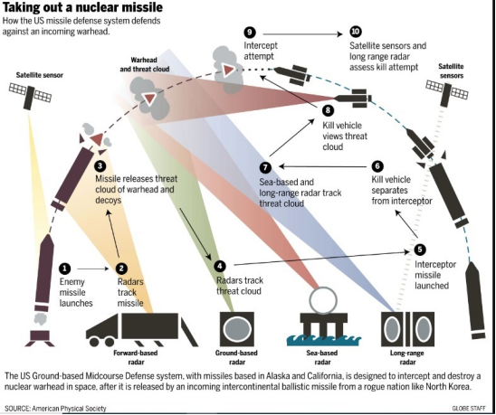

**High Accuracy Detection Exploitation System (HADES)**

**VIII CAPABILITIES**

**YELLOW TEAM**

**AIRCRAFT**

|  |  |
| --- | --- |
| Xian JH6 | * Supersonic Bomber * Can evade air defense and all a/c except US fighter aircraft. * Can deliver payload to target thru supersonic speed * Can carry 4 nuclear tipped missiles |
| Xian JH7 | * Can evade air defense except all US fighter aircraft. * Can deliver payload thru sub-sonic speed; * Can carry 4 nuclear tipped missiles * Fighter bomber |
| MIG 21 (Fishbed) | * Soviet export fighter * can only beat an AV-88 Harrier |
| SU – 17 (Fitter) | * Soviet export fighter * equal to an MIG 29 Fulcrum |
| Shenyang J11 | * can beat Fulcrums and F16 Falcons equal to Superhornets and Flankers |
| Chengdu J20 | * can beat all aircrafts except PAK FA, F22 Raptors, F35 |

**ICBMs**

|  |  |
| --- | --- |
| SLBM DF 41 | 10 MIRVs @ 150 KT Warhead each |
| SLBM J2 | 8 MIRVs @ 150 KT Warhead each |

**SUBS**

|  |  |
| --- | --- |
| SSBN | * XIA Class : carries 12 SLBMs * Jin Class : carries 12 SLBMs |
| SSGN | Kilo Class (Guided Nuclear Submarine) |
| SSN | Qing Class : should avoid any US or RUSSIAN attack submarines and just target air craft carriers |

**SHIPS**

|  |  |
| --- | --- |
| Destroyers | * Submarine Killers except US attack submarines have better sonar capabilities   Luda Class Destroyer  Luhu Class Destroyer  Sovremenny  Luhai |
| Frigates | * Close escorts to the aircraft carrier   Jianghou  Jiangwei  Jiangkai |

**CHINESE SPY SATELLITE :** YAOGUN – Chinese Reconnaissance Satellite

**AIRCRAFT CARRIER:**

|  |  |
| --- | --- |
| Liaoning | * + - * Class Aircraft Carrier   + 4,000 Crew   + 36 Aircraft Fixed/Rotary   12 Shenyang J11  18 SU-27 |
| Shandong | * + - * Latest Chinese Aircraft Carrier   Carries – 24 Shenyang J15   * 8 Change 2-18 * 4 Harbin   + 4,000 Crew |

**CHINA MILITARY CAPABILITIES**

|  |  |  |
| --- | --- | --- |
| **Type** | **Name (English)** |  |
| [Type 054A frigate](https://en.wikipedia.org/wiki/Type_054A_frigate)  [**NATO designation**](https://en.wikipedia.org/wiki/NATO_reporting_name)**:**  Jiangkai II class | [Xuzhou](https://en.wikipedia.org/wiki/Chinese_frigate_Xuzhou_(530)) |  |
| [Zhoushan](https://en.wikipedia.org/wiki/Chinese_frigate_Zhoushan_(529)) |  |
| [Huangshan](https://en.wikipedia.org/wiki/Chinese_frigate_Huangshan_(570)) |  |
| [Hengyang](https://en.wikipedia.org/wiki/Chinese_frigate_Hengyang_(568)) |  |
| [Yuncheng](https://en.wikipedia.org/wiki/Chinese_frigate_Yuncheng_(571)) |  |
| [Yulin](https://en.wikipedia.org/wiki/Chinese_frigate_Yulin_(569)) |  |
| [Yiyang](https://en.wikipedia.org/wiki/Chinese_frigate_Yiyang_(548)) |  |
| [Changzhou](https://en.wikipedia.org/wiki/Chinese_frigate_Changzhou_(549)) |  |
| [Yantai](https://en.wikipedia.org/wiki/Chinese_frigate_Yantai_(538)) |  |
| [Yancheng](https://en.wikipedia.org/wiki/Chinese_frigate_Yancheng_(546)) |  |
| [Hengshui](https://en.wikipedia.org/wiki/Chinese_frigate_Hengshui_(572)) |  |
| [Liuzhou](https://en.wikipedia.org/wiki/Chinese_frigate_Liuzhou_(573)) |  |
| [Linyi](https://en.wikipedia.org/wiki/Chinese_frigate_Linyi_(547)) |  |
| [Yueyang](https://en.wikipedia.org/wiki/Chinese_frigate_Yueyang_(575)) |  |
| [Weifang](https://en.wikipedia.org/wiki/Chinese_frigate_Weifang_(550)) |  |
| [Sanya](https://en.wikipedia.org/wiki/Chinese_frigate_Sanya_(574)) |  |
| [Huanggang](https://en.wikipedia.org/wiki/Chinese_frigate_Huanggang_(577)) |  |
| [Daqing](https://en.wikipedia.org/wiki/Chinese_frigate_Daqing_(576)) |  |
| [Yangzhou](https://en.wikipedia.org/wiki/Chinese_frigate_Yangzhou_(578)) |  |
| [Handan](https://en.wikipedia.org/wiki/Chinese_frigate_Handan_(579)) |  |
| [Jingzhou](https://en.wikipedia.org/wiki/Chinese_frigate_Jingzhou_(532)) |  |
| [Xiangtan](https://en.wikipedia.org/wiki/Chinese_frigate_Xiangtan_(531)) |  |
| [Binzhou](https://en.wikipedia.org/wiki/Chinese_frigate_Binzhou_(515)) |  |
| [Xuchang](https://en.wikipedia.org/wiki/Chinese_frigate_Xuchang_(536)) |  |
| [Wuhu](https://en.wikipedia.org/wiki/Chinese_frigate_Wuhu_(539)) |  |
| [Rizhao](https://en.wikipedia.org/wiki/Chinese_frigate_Rizhao_(598)) |  |
| [Anyang](https://en.wikipedia.org/wiki/Chinese_frigate_Anyang_(599)) |  |
| [Xianning](https://en.wikipedia.org/wiki/Chinese_frigate_Xianning_(500)) |  |
| [Nantong](https://en.wikipedia.org/wiki/Chinese_frigate_Nantong_(601)) |  |
| [Zaozhuang](https://en.wikipedia.org/wiki/Chinese_frigate_Zaozhuang_(542)) |  |
| [Type 054 frigate](https://en.wikipedia.org/wiki/Type_054_frigate)  [**NATO designation**](https://en.wikipedia.org/wiki/NATO_reporting_name)**:**Jiangkai I class | [Ma'anshan](https://en.wikipedia.org/wiki/Chinese_frigate_Ma'anshan_(525)) |  |
| [Wenzhou](https://en.wikipedia.org/wiki/Chinese_frigate_Wenzhou_(526)) |  |
| [Type 053H3 light frigate](https://en.wikipedia.org/wiki/Type_053H3_frigate)  [**NATO designation**](https://en.wikipedia.org/wiki/NATO_reporting_name)**:**  Jiangwei II class | Yichang |  |
| Huludao |  |
| [Sanming](https://en.wikipedia.org/wiki/Chinese_frigate_Sanming_(524)) |  |
| Xiangyang |  |
| Huaihua |  |
| Luoyang |  |
| Mianyang |  |
| [Type 053H1G light frigate](https://en.wikipedia.org/wiki/Type_053_frigate)  [**NATO designation**](https://en.wikipedia.org/wiki/NATO_reporting_name)**:**Jianghu V class | Beihai |  |
| Foshan |  |
| [Type 053H1 light frigate](https://en.wikipedia.org/wiki/Type_053_frigate)  [**NATO designation**](https://en.wikipedia.org/wiki/NATO_reporting_name)**:**  Jianghu II class | Shaoguan |  |

Corvette

|  |  |  |
| --- | --- | --- |
| **Type** | **Name (English)** | **Image** |
| [Type 056 corvette](https://en.wikipedia.org/wiki/Type_056_corvette)  [**NATO designation**](https://en.wikipedia.org/wiki/NATO_reporting_name)**:**  Jiangdao class | Bengbu |  |
| Datong |  |
| Shangrao |  |
| Huizhou |  |
| Meizhou |  |
| Yingkou |  |
| Baise |  |
| Ji'an |  |
| Jieyang |  |
| Weihai |  |
| Luzhou |  |
| Qingyuan |  |
| Fushun |  |
| Quanzhou |  |
| Chaozhou |  |
| Suzhou |  |
| Xinyang |  |
| Huaian |  |
| Heze |  |
| Baoding |  |
| Ningde |  |
| [Type 056A corvette](https://en.wikipedia.org/wiki/Type_056_corvette) | Huangshi |  |
| Sanmenxia |  |
| Zhuzou |  |
| Suqian |  |
| Qinhuangdao |  |
| Jingmen |  |
| Tongren |  |
| Qujing |  |
| Ezhou |  |
| Liupanshui |  |
| Hanzhong |  |
| Yiwu |  |
| Xuancheng |  |
| Yichun |  |
| Guangyuan |  |
| Suining |  |
| Wuhai |  |
| Deyang |  |
| Zhangye |  |
| Nanchong |  |
| Bazhong |  |
| Shuozhou |  |
| Wuzhou |  |
| Wenshan |  |
| Dingzhou |  |
| Panzhihua |  |
| Ganzhou |  |
| Luan |  |
| Liaocheng |  |
| Enshi |  |
| Yongzhou |  |
| Zhangjiakou |  |
| Taian |  |
| Xiaogan |  |
| Guangan |  |
| Mudanjiang |  |
| Jingdezhen |  |
|  | Suizhou |  |
| Xinji |  |
| Dongying |  |
| Shizuishan |  |
| Songyuan |  |
| Tongling |  |
| Tianmen |  |
| Nanyang |  |
| Shangqiu |  |
| Jining |  |
| Shiyan |  |

#### 

### 

### AMPHIBIOUS WARFARE SHIPS

#### MAJOR AMPHIBIOUS WARFARE VESSELS

|  |  |  |
| --- | --- | --- |
| **Type** | **Name (English)** | **Image** |
| [Type 075 landing helicopter dock](https://en.wikipedia.org/wiki/Type_075_landing_helicopter_dock)  [**NATO designation**](https://en.wikipedia.org/wiki/NATO_reporting_name)**:**  Yushen class | [Hainan](https://en.wikipedia.org/wiki/Chinese_landing_helicopter_dock_Hainan) |  |
| [Guangxi](https://en.wikipedia.org/w/index.php?title=Chinese_landing_helicopter_dock_Guangxi&action=edit&redlink=1) |  |
| [Type 071 amphibious transport dock](https://en.wikipedia.org/wiki/Type_071_amphibious_transport_dock)  [**NATO designation**](https://en.wikipedia.org/wiki/NATO_reporting_name)**:**  Yuzhao class | [Kunlun Shan](https://en.wikipedia.org/wiki/Chinese_landing_ship_Kunlun_Shan) |  |
| [Jinggang Shan](https://en.wikipedia.org/wiki/Chinese_landing_ship_Jinggang_Shan) |  |
| [Changbai Shan](https://en.wikipedia.org/wiki/Chinese_landing_ship_Changbai_Shan) |  |
| [Yimeng Shan](https://en.wikipedia.org/wiki/Chinese_landing_ship_Yimeng_Shan) |  |
| Longhu Shan |  |
| Wuzhi Shan |  |
| Siming Shan |  |
| Qilian Shan |  |
| [Type 072A dock landing ship](https://en.wikipedia.org/wiki/Type_072A_landing_ship)  [**NATO designation**](https://en.wikipedia.org/wiki/NATO_reporting_name)**:**  Yuting III class | Tianzhu Shan |  |
| Daqing Shan |  |
| Baxian Shan |  |
| Huading Shan |  |
| Luoxiao Shan |  |
| Daiyun Shan |  |
| Wanyang Shan |  |
| Laotie Shan |  |
| Lühua Shan |  |
| Dabie Shan |  |
| Taihang Shan |  |
| Tianmu Shan |  |
| Wuyi Shan |  |
| Culai Shan |  |
| Wutai Shan |  |
| [Type 072III dock landing ship](https://en.wikipedia.org/wiki/Type_072III_landing_ship)  [**NATO designation**](https://en.wikipedia.org/wiki/NATO_reporting_name)**:**  Yuting II class | Emei Shan |  |
| Danxia Shan |  |
| Xuefeng Shan |
| [Haiyang Shan](https://en.wikipedia.org/wiki/Haiyang_Shan) |  |
| Qingcheng Shan |  |
| Yandang Shan |  |
| Jiuhua Shan |  |
| Putuo Shan |  |
| Huanggang Shan |  |
| Tiantai Shan |  |
| [Type 072II tank landing ship](https://en.wikipedia.org/wiki/Type_072II_landing_ship)  [**NATO designation**](https://en.wikipedia.org/wiki/NATO_reporting_name)**:**  Yukan class | Dongting Shan |  |
| Helan Shan |  |
| Liupan Shan |  |
| [Type 073A helicopter landing ship](file:///E:\China-%20Final%20Aircraft,%20ship,%20subs,%20missile.docx#Type_073A_Yunshu-class_landing_ship)  [**NATO designation**](https://en.wikipedia.org/wiki/NATO_reporting_name)**:**  Yunshu class | Mount Sheng |  |
| Mount Lu |  |
| Mount Meng |
| Mount Jade |  |
| [Mount Hua](https://en.wikipedia.org/wiki/Mount_Hua) |  |
| [Mount Song](https://en.wikipedia.org/wiki/Mount_Song) |  |
| [Mount Lu](https://en.wikipedia.org/wiki/Mount_Lu) |  |
| Snow Mountain |
| [Mount Heng](https://en.wikipedia.org/wiki/Mount_Heng_(Hunan)) |
| [Mount Tai](https://en.wikipedia.org/wiki/Mount_Tai) |  |
| [Type 073III helicopter landing ship](file:///E:\China-%20Final%20Aircraft,%20ship,%20subs,%20missile.docx#Type_073III-class_landing_ship)  [**NATO designation**](https://en.wikipedia.org/wiki/NATO_reporting_name)**:**  Yudeng class | Mount Golden City |  |
| [Type 074A medium landing ship](https://en.wikipedia.org/wiki/Type_074A_landing_ship)  [**NATO designation**](https://en.wikipedia.org/wiki/NATO_reporting_name)**:** Yubei class |  | |
|
|
|
|
|
|
|
|
|
|
| [Type 074 medium landing ship](https://en.wikipedia.org/wiki/Type_074_landing_ship)  [**NATO designation**](https://en.wikipedia.org/wiki/NATO_reporting_name)**:**  Yuhai class |  | |
|
|
|
|
|
|
|
|
|
|
|
| [Type 271IIIA landing ship medium](file:///E:\China-%20Final%20Aircraft,%20ship,%20subs,%20missile.docx#Type_271IIIA_landing_ship_medium)  [**NATO designation**](https://en.wikipedia.org/wiki/NATO_reporting_name)**:**  Yulü class |  | |

#### 

#### MINOR AMPHIBIOUS WARFARE CRAFTS

|  |  |
| --- | --- |
| **Type** | **Image** |
| [Type 067 utility landing craft](https://en.wikipedia.org/wiki/Type_067_utility_landing_craft)  [**NATO designation**](https://en.wikipedia.org/wiki/NATO_reporting_name)**:**  Yunnan class |  |
| [Type 068 landing craft mechanized](file:///E:\China-%20Final%20Aircraft,%20ship,%20subs,%20missile.docx#Type_068/069_landing_craft)  [**NATO designation**](https://en.wikipedia.org/wiki/NATO_reporting_name)**:**  Yuch’in class |  |
| [Type 724 LCAC](https://en.wikipedia.org/wiki/Type_724_LCAC)  [**NATO designation**](https://en.wikipedia.org/wiki/NATO_reporting_name)**:**  Payi class |  |
| [Type 726 LCAC](https://en.wikipedia.org/wiki/Type_726_LCAC)  [**NATO designation**](https://en.wikipedia.org/wiki/NATO_reporting_name)**:**  Yuyi class |  |
|
|
| [Type 726A](https://en.wikipedia.org/wiki/Type_726_LCAC)  [**NATO designation**](https://en.wikipedia.org/wiki/NATO_reporting_name)**:**  Yuyi class |  |
|
|
|
|
|
|
|
|
|
|
|
| [Project 1232.2 (LCAC)](https://en.wikipedia.org/wiki/Zubr-class_LCAC)  [**NATO designation**](https://en.wikipedia.org/wiki/NATO_reporting_name)**:**  Pomornik class |  |
|  |
| [Type 958 LCAC](https://en.wikipedia.org/wiki/Zubr-class_LCAC)  [**NATO designation**](https://en.wikipedia.org/wiki/NATO_reporting_name)**:**  Pomornik class |  |
|
|
|

## AUXILIARY FLEET

## REPLENISHMENT OILERS

|  |  |  |
| --- | --- | --- |
| **Class** | **Type** | **Picture** |
| [Type 903 Fuchi](https://military-history.fandom.com/wiki/Qiandaohu_class_replenishment_ship) | [Replenishment oiler](https://military-history.fandom.com/wiki/Replenishment_oiler) |  |
| [Fusu](https://military-history.fandom.com/wiki/Fusu_class_replenishment_ship) | [Replenishment oiler](https://military-history.fandom.com/wiki/Replenishment_oiler) |  |
| [Fuqing](file:///E:\China-%20Final%20Aircraft,%20ship,%20subs,%20missile.docx#Background) | [Replenishment oiler](https://military-history.fandom.com/wiki/Replenishment_oiler) |  |

## Submarines

### Nuclear-powered submarine

[**Ballistic missile submarine (SSBN)**](https://military-history.fandom.com/wiki/Ballistic_missile_submarine)

|  |  |  |
| --- | --- | --- |
| **Class** | **Picture** | **Displacement** |
| [Type 094](https://military-history.fandom.com/wiki/Type_094_submarine" \o "Type 094 submarine)  [Nato Designation:](https://military-history.fandom.com/wiki/Type_094_submarine" \o "Type 094 submarine)  [Jin](https://military-history.fandom.com/wiki/Type_094_submarine" \o "Type 094 submarine)  **Quantity**: 3 |  | 9,000 tonnes |
| [Type 092](https://military-history.fandom.com/wiki/Type_092_submarine)  **Nato Designation:** Xia  **Quantity**: 1 |  | 7,000 tonnes |

[**Attack submarine (SSN)**](https://military-history.fandom.com/wiki/SSN_(hull_classification_symbol))

|  |  |  |
| --- | --- | --- |
| [Type 093](https://military-history.fandom.com/wiki/Type_093_submarine" \o "Type 093 submarine)  [Nato Designation: Shang](https://military-history.fandom.com/wiki/Type_093_submarine" \o "Type 093 submarine)  [Quantity: 2](https://military-history.fandom.com/wiki/Type_093_submarine" \o "Type 093 submarine) |  | 6,500 tonnes |
| [Type 091](https://military-history.fandom.com/wiki/Type_091_submarine" \o "Type 091 submarine)  [Nato Designation:](https://military-history.fandom.com/wiki/Type_091_submarine" \o "Type 091 submarine)  [Han](https://military-history.fandom.com/wiki/Type_091_submarine" \o "Type 091 submarine)  **Quantity:** 3 |  | 5,500 tonnes |

### Conventionally-powered submarines

[**Ballistic missile submarine**](https://military-history.fandom.com/wiki/Ballistic_missile_submarine)

|  |  |  |
| --- | --- | --- |
| **Class** | **Picture** | **Displacement** |
| [Type 032](https://military-history.fandom.com/wiki/Type_032_submarine" \o "Type 032 submarine)  [Nato Designation:](https://military-history.fandom.com/wiki/Type_032_submarine" \o "Type 032 submarine)  [Qing](https://military-history.fandom.com/wiki/Type_032_submarine" \o "Type 032 submarine)  **Quantity :** 1 |  | 6,628 tonnes |

[**Attack submarine**](https://military-history.fandom.com/wiki/SSN_(hull_classification_symbol))

|  |  |  |
| --- | --- | --- |
| **Class** | **Picture** | **Displacement** |
| [Type 041](https://military-history.fandom.com/wiki/Type_041_submarine" \o "Type 041 submarine)  [Nato Designation: Yuan](https://military-history.fandom.com/wiki/Type_041_submarine" \o "Type 041 submarine)  **Quantity:** 10 |  | 4,000 tonnes |
| [Type 039](https://military-history.fandom.com/wiki/Type_039_submarine" \o "Type 039 submarine)  [Nato Designation:Song](https://military-history.fandom.com/wiki/Type_039_submarine" \o "Type 039 submarine)  **Quantity**: 13 |  | 2,250 tonnes |
| **Nato Designation:**  [Kilo-class](https://military-history.fandom.com/wiki/Kilo-class_submarine)  **Quantity:** 12 |  | 3,900 tonnes |

|  |  |  |  |
| --- | --- | --- | --- |
| TYPE | NAME | IMAGE | DESCRIPTION |
|  | [**DF-11**](https://missilethreat.csis.org/missile/dong-feng-11/) |  | **WARHEAD**  Nuclear 2/10/20 kt, HE, submunitions, FAE, or chemical  RANGE:280 - 300 km |
|  | [**DF-12 / M20**](https://missilethreat.csis.org/missile/df-12/) |  | **WARHEAD**  High-explosive, submunition, earth-penetrator, thermobaric  RANGE:280 km |
|  | [**DF-15**](https://missilethreat.csis.org/missile/df-15-css-6/) |  | **WARHEAD**  Nuclear, HE, submunitions  RANGE:600 km |
|  | [**DF-16**](https://missilethreat.csis.org/missile/dong-feng-16-css-11/) |  | **WARHEAD**  1-3 HE, submunition, nuclear  RANGE:800 - 1,000 km |

**Short Range Ballistic Missile**

**Medium-range Ballistic Missile (MRBM) / Hypersonic Glide Vehicle (HGV)**

|  |  |  |  |
| --- | --- | --- | --- |
| TYPE | NAME | IMAGE | DESCRIPTION |
|  | [**DF-17**](https://missilethreat.csis.org/missile/df-17/) |  | RANGE:1,800 - 2,500 km |

**Medium-range, road-mobile ballistic missile.**

|  |  |  |  |
| --- | --- | --- | --- |
| TYPE | NAME | IMAGE | DESCRIPTION |
|  | [**DF-21**](https://missilethreat.csis.org/missile/df-21/) |  | **WARHEAD**  250 or 500 kT nuclear or conventional high-explosive  RANGE:2,150 km |

**Intermediate-range ballistic missile (IRBM).**

|  |  |  |  |
| --- | --- | --- | --- |
| TYPE | NAME | IMAGE | DESCRIPTION |
|  | [**DF-26**](https://missilethreat.csis.org/missile/dong-feng-26-df-26/) |  | **WARHEAD**  Nuclear, conventional  RANGE:4,000 km |

|  |  |  |  |
| --- | --- | --- | --- |
| TYPE | NAME | IMAGE | DESCRIPTION |
|  | [**DF-31**](https://missilethreat.csis.org/missile/df-31/) |  | **WARHEAD**  Single warhead, 500kg, 200 – 300kt nuclear  RANGE:7,000 - 11,700 km |
|  | [**DF-4**](https://missilethreat.csis.org/missile/df-4/) |  | **WARHEAD**  Single nuclear warhead, 1-3 MT yield  RANGE:4,500 - 5,500 km |
|  | [**DF-41**](https://missilethreat.csis.org/missile/df-41/) |  | **WARHEAD**  Up to 10 nuclear warheads; MIRV  RANGE:12,000 - 15,000 km |
|  | [**DF-5**](https://missilethreat.csis.org/missile/df-5-ab/) |  | **WARHEAD**  Nuclear, 1-3 MT, Single warhead (DF-5A), Multiple warheads (DF-5B)  RANGE:13,000 km |

**Intercontinental ballistic missile (ICBM)**

**Short- and intermediate-range cruise missiles**

|  |  |  |  |
| --- | --- | --- | --- |
| TYPE | NAME | IMAGE | DESCRIPTION |
|  | [**HN 2**](https://missilethreat.csis.org/missile/hong-niao/) |  | **WARHEAD**  High-explosive, submunitions, or 20-90 kT nuclear  RANGE:1,400-1,800 km |
|  | [**HN 3**](https://missilethreat.csis.org/missile/hong-niao/) |  | **WARHEAD**  High-explosive, submunitions, or 20-90 kT nuclear  RANGE:3,000 km |
|  | [**HN 1**](https://missilethreat.csis.org/missile/hong-niao/) |  | **WARHEAD**  High-explosive, submunitions, or 20-90 kT nuclear  RANGE:50 - 650 km |
|  | [**YJ-18**](https://missilethreat.csis.org/missile/yj-18/) |  | **WARHEAD**  High-explosive or antiradiation  140-300 Kg(310-660 lb)  RANGE:8,000 - 9,000 km |

**Intercontinental-range submarine-launched ballistic missile**

|  |  |  |  |
| --- | --- | --- | --- |
| TYPE | NAME | IMAGE | DESCRIPTION |
|  | [**JL-2**](https://missilethreat.csis.org/missile/jl-2/) |  | **WARHEAD**  High-explosive or antiradiation  RANGE:220 - 540 km |

**IX CAPABILITIES**

**GREEN TEAM**

**AIRCRAFT**

|  |  |
| --- | --- |
| Rafale | * Can beat F-16s and Fulcrums, Fishbed and Fitters equal to Flankers and Hornets |
| Tejas | * Can beat F-16s, Fitter, Fishbed equal to Hornets, Fulcrums and Shenyang |
| Mirage 2000 | * Can beat all aircraft except Flankers, Superhornets, PAK FA equal to Chengdu J20 |
| Jaguar | * Can beat Fishbed and Fritter equal to F-16 |

**AIRCRAFT CARRIER**

|  |  |
| --- | --- |
| Vikraant | * Latest Indian Aircraft Carrier   Carries: 24 Rafale  12 Jaguars   * Indian Aircraft Carrier Battle Group composed of:   + 2 Destroyers   + 2 Frigates   + 4 Corvettes * 4,000 Officers and Crew |
| Vikramaditya | 1. Carrier acquired from Russia   Carries: 24 Rafale  12 Jaguars   * + 4,000 Officers and Crew |

**ICBM**

AGNI VI : II MIRVs @ 150 KT/Warhead

**INDIAN SPY SATELLITE :** RISAT 2 : Indian Radar / Reconnaissance Satellite

**INDIA MILITARY CAPABILITIES**

|  |  |  |
| --- | --- | --- |
| Class | Name | Picture |
| **AIRCRAFT CARRIER** | | |
| **Vikrant Class** | INS Vikrant |  |
|  | INS Vikramaditya |  |
| **SSBN** | | |
| **Arihant Class** | INS Arihant(S2) |  |
| **SSK** | | |
| **Kalvari Class** | INS Kalvari |  |
|  | INS Khanderi (S22) |  |
|  | INS Karanj (S23 |  |
|  | INS Vela (S24) |  |
| **Sindhughosh Class** | INS Sindhughosh (S55) |  |
|  | INS Sindhuraj (S57) |  |
|  | INS Sindhuratna (S59) |  |
|  | INS Sindhukesari (S60) |  |
|  | INS Sindhukirti (S61) |  |
|  | INS Sindhuvijay (S62) |  |
|  | INS Sindhurashtra (S65) |  |
| **Shishumar Class** | INS Shishumar (S44) |  |
|  | INS Shankush (S45) |  |
|  | INS Shalki (S46) |  |
|  | INS Shankul (S47) |  |
| **Amphibious Warfare Ships** | | |
| **Austin Class** | INS Jalashwa (L41) |  |
| **Landing Ship Tanks** | | |
| **Magar Class** | INS Magar (L20) |  |
|  | INS Gharial (L23) |  |
| **Shardul Class** | INS Shardul (L16) |  |
|  | INS Kesari (L15) |  |
|  | INS Airavat (L24) |  |
| **Kumbhir Class** | INS Cheetah (L18) |  |
|  | INS Guldar (L21) |  |
|  | INS Kumbhir (L22) |  |
| **Landing Craft Utility** | | |
| **Mk. IV LCU** | INS LCU 51 (L51) |  |
|  | INS LCU 52 (L52) |
|  | INS LCU 53 (L53) |
|  | INS LCU 54 (L54) |
|  | INS LCU 55 (L55) |
|  | INS LCU 56 (L56) |
|  | INS LCU 57 (L57) |
|  | INS LCU 58 (L58) |
| **Destroyers** | | |
| **Visakhapatnam Class** | INS Visakhapatnam (D66) |  |
| **Kolkata Class** | INS Kolkata (D63) |  |
|  | INS Kochi (D64) |  |
|  | INS Chennai (D65) |  |
| **Delhi Class** | INS Mysore (D60) |  |
|  | INS Delhi (D61) |  |
|  | INS Mumbai (D62) |  |
| **Rajput Class** | INS Rana (D52) |  |
|  | INS Ranvir (D54) |  |
|  | INS Ranvijay (D55) |  |
| **Frigates** | | |
| **Shivalik Class** | INS Shivalik (F47) |  |
|  | INS Satpura (F48) |  |
|  | INS Sahyadri (F49) |  |
| **Talwar Class** | INS Talwar (F40) |  |
|  | INS Trishul (F43) |  |
|  | INS Tabar (F44) |  |
|  | INS Teg (F45) |  |
|  | INS Tarkash (F50) |  |
|  | INS Trikand (F51) |  |
| **Brahmaputra Class** | INS Brahmaputra (F31) |  |
|  | INS Betwa (F39) |  |
|  | INS Beas (F37) |  |
| **Corvettes** | | |
| **Kamorta Class** | INS Kamorta (P28) |  |
|  | INS Kadmatt (P29) |  |
|  | INS Kiltan (P30) |  |
|  | INS Kavaratti (P31) |  |
| **Kora Class** | INS Kora (P61) |  |
|  | INS Kirch (P62) | ­­­­­­­­­­­­­ |
|  | INS Kulish (P63) |  |
|  | INS Karmuk (P64) |  |
| **Khukri Class** | INS Kuthar (P46) |  |
|  | INS Kirpan (P44) |  |
|  | INS Khanjar (P47) |  |
| **Veer Class** | INS Vibhuti (K45) |  |
|  | INS Vipul (K46) |  |
|  | INS Vinash (K47) |  |
|  | INS Vidyut (K48) |  |
|  | INS Nashak (K83) |  |
|  | INS Pralaya (K91) |  |
|  | INS Prabal (K92) |  |
| **Abhay Class** | INS Abhay (P33) |  |
|  | INS Ajay (P34) |  |
| **Offshore Patrol Vessels** | | |
| **Saryu Class** | INS Saryu (P54) |  |
|  | INS Sunayna (P57) |  |
|  | INS Sumedha (P58) |  |
|  | INS Sumitra (P59) |  |
| **Sukanya Class** | INS Sukanya (P50) |  |
|  | INS Subhadra (P51) |  |
|  | INS Suvarna (P52) |  |
|  | INS Savitri (P53) |  |
|  | INS Sharada (P55) |  |
|  | INS Sujata (P56) |  |
| **Patrol Vessels** | | |
| **Car Nicobar Class**  **Fleet I** | INS Car Nicobar (T69) |  |
|  | INS Chetlat (T70) |  |
|  | INS Kora Divh (T71) |  |
|  | INS Cheriyam (T72) |  |
|  | INS Cankaraso (T73) |  |
|  | INS Kondul (T74) |  |
|  | INS Kalpeni (T75) |  |
|  | INS Kabra (T76) |  |
|  | INS Koswari (T77) |  |
|  | INS Karuva (T78) |  |
| **Fleet II** | INS Tarmugli (T91) |  |
|  | INS Tillanchang(T92) |  |
|  | INS Tihayu (T93) |  |
|  | INS Tarasa (T94) |  |
| **Bangaram Class** | INS Bangaram (T65) |  |
|  | INS Bitra (T66) |  |
|  | INS Batti Malv (T67) |  |
|  | INS Baratang (T68) |  |
| **Trinkat Class** | INS Trinkat (T61) |  |
| **AIRCRAFT** | | |
| **Combat Aircraft** | Dassault Rafale |  |
|  | Sukhoi Su-30  NATO Reporting Name: Flanker-C/G/H |  |
|  | HAL Tejas |  |
|  | MiG-29  NATO Reporting Name: Fulcrum |  |
|  | Mirage 2000 |  |
|  | SEPECAT Jaguar |  |
|  | MiG-21  NATO Reporting Name: Fishbed |  |
| **AWACS** | EMB-145 |  |
|  | Beriev A-50 |  |
|  | Kamov Ka-31 |  |
| **MARITIME PATROL** | | |
|  | Boeing P-8 |  |
|  | Ilyushin Il-38 |  |
|  | Dornier Do 228 |  |
|  | Britten-Norman BN-2 |  |
| **Reconnaissance** | Boeing 707 |  |
|  | Boeing 737 |  |
|  | Global 5000 |  |
|  | Gulfstream G100 |  |
| **Electronic Warfare** | Gulfstream III |  |
| **Boeing 777** | Air India One |  |
| **HELICOPTERS** | | |
|  | HAL Light Combat Helicopter |  |
|  | Boeing AH-64 Apache |  |
|  | HAL Rudra |  |
|  | SH-60 Seahawk |  |
|  | Kamov Ka-27 |  |
|  | Sikorsky SH-3 Sea King |  |
| **U A V** | | |
|  | IAI Heron TP |  |
|  | IAI Heron |  |
|  | IAI Searcher |  |
|  | IdeaForge Switch |  |
|  | General Atomics MQ-9 Reaper |  |
|  | DRDO Lakshya |  |
| **SURFACE TO AIR MISSILES** | | |
| **SRBM** | Prithvi Missile Series –  High explosives, penetration, cluster munition, fragmentation, thermobaric, chemical weapon and tactical n uclear weapon  Conventional / Nuclear  Accuracy :  50 m [CEP](https://en.wikipedia.org/wiki/Circular_error_probable) (Prithvi I, Prithvi II) <10 m [CEP](https://en.wikipedia.org/wiki/Circular_error_probable) (Prithvi II upgrade)[[3]](file:///C:\Users\J%20Prado\Downloads\India%20Edited%208%2012%2022.docx#cite_note-3) 25 m [CEP](https://en.wikipedia.org/wiki/Circular_error_probable) (Prithvi III) |  |
| **Medium – ICBM W/ MIRV** | Agni Missile Series  CONVENTIONAL / NUCLEAR |  |
| **ICBM** | AGNI VI  Strategic nuclear weapon with 10-11 MIRV capability |  |
| **SLBM** | K-15 SAGARIKA  Conventional / NUCLEAR |  |

**IX RESOURCES**

**RED TEAM**

**COMMAND AND CONTROL CENTER**

1. Moscow, Russia
2. Tunguska, Russia
3. Murmansk, Russia
4. Milkovo, Russia
5. Vladivostok, Russia
6. Arkangel, Russia
7. Petrozavodsk
8. Bulshevik, Russia (Secret Base)

**AIR BASE**

1. **VLADIVOSTOK**

48 SU33 Flanker-D

48 MiG49 Fulcrum

48 SVU PAK FA,

2 Ilyushin May

26 TU22 Backfire

1. **KAMCHATKA PENINSULA**

24 TU16 Badger

22 TU24 Backfire

12 MiG25 Foxbat

12 MiG32 Foxhound

36 SU24 Fencer

1. **PONOY**

48 SU24 Fencer

24 TU16 Badger

24 TU24 Backfire

36 MiG49 Fulcrum

1. **PECHENGA**

48 TU24 Backfire

48 TU16 Badger

2 Mainstay

24 Mig32 Foxhound

24 MiG25 Foxbat

24 PAK FA/Felon

48 SU24 Fencer

3 Ilyushin May

2 Bear

1. **KIROVSK**

48 TU24 Backfire

2 Mainstay

24 SU33 Flanker-D

24 SU24 Fencer

1. **ODESSA**

24 SU24 Fencer

12 MiG49 Fulcrum

1 Ilyushin May

1. **KURSK**

24 SU33 Flanker-D

24 MiG49 Fulcrum

1. **NORGOROD**

48 SU33 Flanker-D

48 MiG25 Foxbat

1. **GROZNYY**

24 SU33 Flanker-D

12 Fishbed

12 Fitter

1. **KRASNUDAR**

24 SU33 Flanker-D

1. **VOLGOGRAD**

24 Backfire

12 Foxhound

12 Fulcrum

1. **PROVIDENIYA**

48 Backfire

48 Badger

24 Flanker

24 Foxhound

4 Mainstay

1. **IRKUTSK**

24 Backfire

24 Foxhound

24 Flanker

36 Pakfa

1. **ASTANA, KAZAKHSTAN**

24 Flanker

36 Fulcrum

24 Foxhound

12 Foxbat

12 Fishbed

12 Fitter

1 Mainstay

1. **LENINOGORSK**

24 Backfire

12 Foxhound

12 Fulcrum

1 Bear

1. **CHELYABINSK**

24 Flanker

36 Fulcrum

1. **SMOLENSK**

48 Pak Fa

48 Foxhound

48 Fulcrum

12 Backfire

1. **KRASNOYARSK**

48 Flanker

48 Fulcrum

1. **SKOVORODINO**

60 Backfire

100 Pak fa

100 Flanker

2 Mainstay

**HARBOR**

1. **POLYYARNY, MURMANSK**

1 Borei Class SSBN

3 Oscar Class SSGN

2 Charlie SSGN

4 Kilo Class SSGN

1 Sierra Class SSN

1 Akula SSN

1 Victor SSN

1. **ARKANGEL**

1 Kirov Class Battlecruiser

3 Udaloy Destroyers

1 Slava

1 Neustrashimyy

1. **YALTA**

1 Udaloy Destroyer

1 Krivak Frigate

4 Kilo Class SSGN

1. **KALININGRAD**

5 Charlie Class SSGN

2Sierra Class

I Victor Class

1. **KORSAKOV**

1 Kirov Class Battlecruiser

1 Udaloy Class

2 Gepard Class

3 Kilo Class SSGN

1. **PROVIDENIYA**

3 Admiral Grigorovich Frigate

1 Borei Class SSBN

1. **KAMCHATKA PENINSULA**

2 Kilo Class SSGN

2 Charlie Class SSGN

1 Udaloy Destroyer

1. **VYBORG**

1 Udaloy Destroyer

1 Slava

3 Oscar Class

1. **WONSAN, NORTH KOREA**

2 Charlie Class SSGN

1. **CUBA**

4 Kilo Class SSGN

5 Charlie Class SSGN

1 Alfa Class

1 Akula SSN

**SILOS**

1. (Capability Facts: 1 Regiment = 30 Silos )

**ICBM**

1st Regiment: Pechora, Russia

2nd Regiment: Khatanga, Russia

3rd Regiment: Apuka, Russia

4th Regiment: Tunguska, Russia

5th Regiment: Oktgvabrskoye,Russia

6th Regiment: Chelyabinsk, Russia

7th Regiment: Novosibirsk, Russia

8th Regiment: Plesetsk, Russia

9th Regiment: Komsomol’sk, Russia

10th Regiment: Leninogorsk, Russia

11th Regiment: Svobodny, Russia

12th Regiment: Biysk, Russia

13th Regiment: Smolensk, Russia

14th Regiment: Uralski, Russia

15th Regiment: Vanavara, Russia

16th Regiment: Kirensk, Russia

17th Regiment: Kabharovsk, Russia

18th Regiment: Serov, Russia

19th Regiment: Vologda, Russia

20th Regiment: Vitim, Russia

21st Regiment: Kazan, Russia

**IRBM (Mobile Launcher)**

* Uelen, Russia
* Vanadir, Russia
* Havana, Cuba
* Belgorod, Russia
* Stavropol, Russia

**BATTLE GROUPS**

1. Admiral Kuznetsov Strike Group

* Location: Eastern Pacific 68° latitude x 8° longitude, Norwegian Sea
* 1 Kirov Class Battle Cruisers, 1 Udaloy Destroyer, 1 Slava Cruiser, 1 Krivak Frigate, 1 Neustrashimyy Class Frigate, 1 Sierra Class SSN

**AMPHIBIOUS GROUPS**

* + Group 1

Location: 69° latitude x 13° longitude, Denmark Strait,

Capability: 1 Sovremmeny Destroyer, 2 Admiral Gorshkov Frigates, 3 Alligator Class LST, 2 Ivan Rogov LST, 3 Kalmar Class LCAC, 3 Aist Class LCAL

* + Group 2

Location: 69° latitude x 3° longitude, Norwegian Sea

Capability: 1 Kirov Class Battle Cruiser, 1 Sovremmeny Class Destroyer, 2 Akula Class SSN, 3 Aist Class LCAC, 1 Tsaplya LCAC, 2 Zubr Class LCAC

**SSBN**

1. Typhoon Class Location : 57° latitude x 145° longitude, Gulf of Alaska
2. Borei Class 1 Location : 60° latitude x 80° longitude, Hudson Bay
3. Borei Class 2 Locaiton : 30° latitude x 50° longitude, Northwest Atlantic
4. Borei Class 3 Location : 33° latitude x 155° longitude, Central Pacific
5. Borei Class 4 Location : 40° latitude x 15° longitude, East Atlantic
6. Borei Class 5 Location : Kamchatka Peninsula
7. Borei Class 6 Location : 15° latitude x 62° longitude, Indian Ocean

**SSGN**

1. Oscar 1 Location : Kamchatka Peninsula
2. Oscar 2 Location : 20° latitude x 138° longitude, Philippine Sea
3. Oscar 3 Location : 15° latitude x 170° longitude, Central Pacific

**SSN**

1. Akula 1 Location : 0° latitude x 78° longitude, Indian Ocean
2. Akula 2 Location : 60° latitude x 40° longitude, Northeast Atlantic
3. Akula 3 Location : 74° latitude x 28° longitude, Barents Sea
4. Alpha 1 Location : 45° latitude x 35° longitude, Northwest Atlantic
5. Alpha 2 Location : 12° latitude x 116° longitude, South China Sea
6. Alpha 3 Location : 34° latitude x 122° longitude, Yellow Sea
7. Alpha 4 Location : 70° latitude x 10° longitude, Norwegian Sea
8. Alpha 5 Location : 30° latitude x 130° longitude, East Pacific

**OIL RIGS OF RUSSIA**

(1 Symbol is equivalent to 100 Oil Wells)

1. Balkash
2. Karaganda
3. Ayaguz
4. Aral’sk
5. Chelkar

**IX RESOURCES**

**BLUE TEAM**

**COMMAND AND CONTROL CENTER**

1. Washinton, D.C.
2. Cheyenne Mountain, Colorado
3. Omaha, Nebraska
4. Oahu Island, Hawaii
5. Anchorage, Alaska (Secret Base)
6. San Diego, California
7. Albuquerque, New Mexico
8. Buffalo, New York

**AIR BASE**

1. **HICKAM AIR FIELD, HAWAII**

2 sentries

12 B52 Bombers

12 B1B Lancers

12 B2A Spirit

24 F16 Falcons

48 F15C Eagle

3 PC3 Orion

1. **GUAM**

1 Sentry

48 B52 Bombers

48 B2A Spirit

24 F15C Eagles

2 PC3 Orion

1. **AZORES, PORTUGAL**

2 Sentry

12 F15 Eagle

12 B52 Bomber

2 PC3 Orion

12 B1B Lancer

1. **DIEGO GARCIA**

24 B52 Bomber

24 B1B Lancers

24 B2A Spirit

2 Sentries

48 F15C Eagle

24 F15E Strike Eagle

1. **MILAN AIR BASE, ITALY**

24 B52 Bomber

12 F15 Eagle

12 F22 Raptor

1. **GOOSE, CANADA**

24 B52 Bomber

12 F18C Hortet

12 F35 Lightning

12 F22 Raptor

1. **OMAHA, NEBRASKA**

60 B52 Bomber

12 B1 Lancer

12 B2 Spirit

24 F22 Raptor

1. **LE HAVRE, FRANCE**

48 F16 Falcon

48 F35 Lightning

488 F22 Raptor

1. **KEFLAVIK, ICELAND**

2 Sentry

24 F15 Eagle

24 F22 Raptor

24 F35 Lightning

4 PC3 Orion

1. **KODIAK AIR BASE, ALASKA**

24 F18E Superhornet

24 F18F Superhornet

24 F35 Lightning

12 F15C Eagle

1. **NAGOYA, JAPAN**

24 F18E Superhornet

12 F15 Eagles

24 F15E Strike Eagles

48 A-10 Thunderbolt

1. **TANAGA AIR BASE, ALEUTIAN ISLANDS**

12 F16 Falcon

12 F15C Eagle

1. **ANDREWS AIRBASE, VIRGINIA**

1 747-700 Airforce 1

24 F15C Eagle

24 F22 Raptor

1. **EDINBURGH SCOTLAND, UK**

2 Sentry

12 F16C Falcons

48 A-10 Thunderbolt

48 F15E Strike Eagle

1. **GREENLAND**

24 B52 Bomber

1. **MIDWAY ISLAND**

12 F35 Lightning

1 PC3 Orion

1. **WAKE ISLAND**

1 Sentry

12 F18F Superhornet

1. **ST. JOHN’S AIRBASE**

24 F15 Eagle

48 B52 Bomber

1. **OSAKA AIR BASE, JAPAN**

24 F18E Superhornet

24 F18F Superhornet

2 Sentry

5 PC3 Orion

1. **TEL AVIV, ISRAEL**

36 F16C Falcon

24 F15C Eagle

1. **KAOHSIUNG, TAIWAN**

36 F18C Hornet

1. **SPOKANE, WASHINGTON**

12 B2A Spirit

1. **WYNDHAM, AUSTRALIA**

24 F22 Raptor

24 F35 Lighting

24 F16 Falcon

1. **BERGEN NORWAY**

24 F16 Falcon

1. **PITUFFIK, GREENLAND**

**HARBOR**

1. **PEARL HARBOR**

1 Carrier Dwight Eisenhower

1 Carrier Harry Truman

USS Bataan USS Carney

USS Iwo Jima USS Shoup

USS Tripoli USS Kidd

USS San Diego USS Rafael Peralta

USS Green Bay USS Wichita

USS Oak Hill USS Mitscher

USS Tortuga USS St. Louis

USS Chosin USS Tulsa

USS Anzio

USS Wyoming (SSBN)

USS Springfield (SSN)

USS New Mexico (SSN)

1. **NORFOLK, VIRGINIA**

USS John Stennis

USS Boxer

USS Arlington

USS Monterey

USS Oscar Austin

USS Frank Petersen

USS Mobile

USS Georgia (SSGN)

USS Boise (SSN)

1. **BANGOR, MAINE**

USS Charleston

USS Albany (SSN)

USS Topeka (SSN)

USS Scranton (SSN)

USS Santa Fe (SSN)

USS Cheyenne (SSN)

USS Oregon (SSN)

1. **SAN DIEGO**

USS Theodore Roosevelt

USS Mesa Verde

USS Pearl Harbor

USS Ashland

USS Shiloh

USS Curtis Wilbur

USS Laboon

USS Gridley

USS Michael Monsoor

USS Little Rock

USS Milwaukee

USS Gabrielle Giffords

USS Hartford (SSN)

USS Colorado (SSN)

1. **AZORES, PORTUGAL**

USS John Murtha

USS Princeton Cruiser

1. **DIEGO GARCIA**

USS Cole

USS Minneapolis

USS Cincinnati

1. **SUBIC BAY, PHILIPPINES**

USS Chicago (SSN)

USS Kansas City

1. **OKINAWA, JAPAN**

USS Anchorage

USS Cape St. George

1. **NEW YORK HARBOR**

USS Nimitz

USS Port Royal

USS John Paul Jones

USS Stout

1. **SEATTLE**

USS Paul Ignatius

USS Jackson (SSBN)

1. **ANCHORAGE, ALASKA**

USS Louisiana (SSBN)

USS Jimmy Carter (SSN)

1. **REYKJAVIK, ICELAND**

USS John McCaine

1. **INCHEON, SOUTH KOREA**

USS Higgins

1. **DARWIN, AUSTRALIA**

USS McFaul

1. **BREWSTER, GREENLAND**

USS Spruance

1. **BODO, NORWAY**

USS Oakland

1. Dutch Harbor, Aleutian Island

USS Vermont (SSN)

1. **ISTANBUL, TURKEY**

USS Savannah

1. **TOKYO, JAPAN**

USS Zumwalt

**AIRCRAFT CARRIER**

1. Ford Carrier Strike Group

Ford Class Aircraft Carrier

Location : Philippine Sea, 19° latitude 100° longitude

Goerge Washington

Bunkerhill

Mobile Bay

Antiatam

Leyte Gulf

San Jacinto

Philippine Sea

Arleigh Burke

Barry

Russel

Paul Hamilton

Ramage

Fitzgerald

Stethem

Forthworth

Coronado

Ohio

Providence

Chicago

1. Carl Vinson

Location : 5° latitude 88° longitude

Normandy

Chancellorsville

Benfold

Gonzales

The Sullivans

Indianapolis

Montegomery

1. Abraham Lincoln

Location : 55° latitude 17° longitude

Cowpence

Mellius

Hopper

Ross

1. Ronald Reagan

Location : 47° latitude 168° longitude

Mt Whitney

Gettysburgh

Hué City

Mahan

Decatur

O’Kane

Porter

Detroit

Omaha

Key West

Oklahoma City

1. George Bush

Location : Persian Gulf, 28° latitude 50° longitude

USS Wasp

San Antonio

Rushmore

Vicksburg

Lake Erie

Donald Cook

Roosevelt

Winston Churchill

Sioux City

Manchester

Florida

**SURFACE SHIP**

**AMPHIBIOUS SURFACE GROUP**

1. **USS Essex**

Location : Philippine Sea, 18° latitude 130° longitude

Blueridge

New Orleans

Harper’s Ferry

German Town

Lassen

Howard

Bulkeley

Billings

Helena

1. **USS Kearsarge**

Location : North Pacific, 40° latitude 152° longitude

Sommerset

Mason

Preble

Delbert Black

1. **USS Makin**

Location : North Atlantic 50° latitude 20° longitude

Portland

Mustin

Chafe

1. **USS America**

Location : Northwest Atlantic, 22° latitude 61° longitude

Fort Lauderdale

Cartel Hall

Comstock

Pinckney

Momsen

Chung-hoon

Nitze

Toledo

Tucson

**SURFACE SHIPS**

1. USS James Williams

Location : Bering Sea, 58° latitude 175° longitude

1. USS Bainbridge

Location : Sea of Japan , 48° latitude 133° longitude

1. USS Halsey and USS Forrest Sherman

Location : South China Sea, 80° latitude 115° longitude

1. USS Sampson and USS Truxton

Location : Davis Straight, 62° latitude 57° longitude

1. USS Patriot

Location : Norwegian Sea, 67° latitude 10° longitude

**DESTROYER**

1. Bay of Bengal, 14° latitude 88° longitude

USS Sterret

USS Dewey

USS Stock Dale

USS Gridley

1. Arabian Sea, 14° latitude 63° longitude

Wayne Meyer

Jason Dunham

William Lawrence

Michael Murphy

**SSBN**

1. USS Henry Jackson

Location : 57° latitude 148° longitude

1. USS Alabama

Location :East China Sea, 32° latitude 125° longitude

1. USS Alaska

Location : 76° latitude 41° longitude

1. USS Nevada

Location : South China Sea, 10° latitude 106° longitude

1. USS Tennessee

Location : Black Sea, 43° latitude 40° longitude

1. USS Pennsylvania

Location : Northwest Atlantic, 30° latitude 71° longitude

1. USS Virginia

Location : Kara Sea 73° latitude 63° longitude

1. USS Kentucky

Location : Mediterranean Sea, 35° latitude 18° longitude

1. USS Maryland

Location : Bay of Bengal, 10° latitude 97° longitude

1. USS Nebraska

Location : Chukchi Sea, 70° latitude 167° longitude

1. USS Rhode Island

Location : Norwegian Sea, 68° latitude 3° longitude

1. USS Maine

Location : Baltic Sea, 58° latitude 18° longitude

**SSN**

1. USS Newport News

Location : 58° latitude 57° longitude, Bering Sea

1. USS San Juan

Location : 48° latitude 145° longitude, Sea of Okhost

1. USS Alexandria

Location : 73° latitude 16 longitude, Norwegian Sea

1. USS Asheville

Location : 38° latitude 65° longitude, Northwest Atlantic

1. USS Jefferson City

Location : 33° latitude 133° longitude

1. USS Annapolis

Location : 68° latitude 28° longitude, Denmark Straight

1. USS Columbia

Location : 16° latitude 135° longitude Philippine Sea

1. USS Seawolf

Location : 70° latitude 40° longitude, Barents Sea

1. USS Connecticut

Location : 40° latitude 17° longitude, Noth Eastern Atlantic

1. USS Virginia Class

Location : 8° latitude 110° longitude, South China Sea

1. USS Texas

Location : 17° latitude 110° longitude, Indian Ocean

1. USS Hawaii

Location : 60° latitude 93° longitude, Hudson Bay

1. USS North Carolina

Location : 72° latitude 78° longitude Foxe Basin

1. USS New Hampshire

Location : 63° latitude 173° longitude Bering Sea

**IX RESOURCES**

**YELLOW TEAM**

**COMMAND AND CONTROL**

1. Beijing
2. Shenyang
3. Nanjing
4. Jinan
5. Xian
6. Xinjiang
7. Baotou
8. Qamdo

**AIR BASES**

1. Hangzhou

60 Xian H-6

48 Shenyang J-11

48 Chengdu J-20

2 Shaanxi Y-9

1. Yinchuan

12 Xian H-6

12 Xian JH-7

24 Shenyang J-11

24 Chengdu J-20

2 Shaanxi Y-9

24 SU-27 Flanker

12 Chengdu Cloud Shadow (Drone)

1. Tianjin

48 Xian H-6

12 Shenyang J-11

48 Chengdu J-20

12 SU-35

1 Shaanxi Y-9

1. Gangzhouo

60 Xian H-6

12 Xian JH-7

12 Shenyang J-11

48 Chengdu J-20

12 Sukhoi Su-27

1. Xianjiang

24 Xian H-6

48 Shenyang J1-1

48 Chengdu J-20

1 Shaanxi Y-9

1. Jiling

12 Xian H-6

12 Chengdu J-20

1. Qira

12 Chengdu J-20

12 Sukhoi Su-35

1. Wuhan

100 Xian H-6

48 Shenyang J-11

48 Chengdu J-20

24 Sukhoi Su-35

4 Shaanxi Y-9

1. Guiyang

48 Sukhoi Su-35

1. Hila

12 Sukhoi Su-30

12 Sukhoi Su-27

12 Chengdu J-20

**HARBOR**

1. Xiamen

1 Jin SSBN

1 Shandong Aircraft Carrier

Nanchang

Wuxi

Hefei

Urumqi

Haikou

Shenyang

Yulin

Wuhu

Yichang

Shangrao

Ji’an

Hainan

Huadingshan

Dabie Shan

1. Tianjin

Guilin

Kaifeng

Baotou

Fuzhou

Shenzhen

Sanya

Anyang

Weihai

Songyuan

Wanyang Shan

1. Shanghai

Bengbu

Datong

Huizhou

Yingkou

Luzhou

Heze

Suzhou

Jinzgmen

Yichun

Guangyuang

Wenshan

Guangan

Tongling

Nanyang

Longhu Shan

Taihang Shan

Yandang Shan

Liupan Shan

1. Xiangtau

Xianyang

Nanjing

Baise

Jieyang

Huangshi

Kunlun Shan

Tianzhu Shan

Wuyi Shan

Putuo Shan

Dongting Shan

1. Zhangjiang

Qilian Shan

Wuzhi Shan

Luhua Shan

Emei Shan

Tiantai Shan

1. Hongkong

Kunming

Jinan

Ningbo

Yiyang

Daqing

Tongren

Ezhou

Guangzhou

Tianmu Shan

Haiyang Shan

SILOS

1. Anxi
2. Yumen
3. Pouding
4. Linshuan
5. Qaram
6. Nenjiang
7. Wuwei
8. Tiongdo
9. Tiongde
10. Harbin

**BATTLE GROUP**

* Liaoning Carrier Battle Group

Location : 18° latitude 110° longitude, South China Sea

Lhasa

Dalian

Yan’an

Zunyi

Xianyang

Changsha

Yinchuan

Tangshan

Qingdao

Wuhan

Huangshan

Yueyang

Linyi

Yangzhou

Handan

Huaihua

Luoyang

Meizhou

Xinyang

**SURFACE SHIPS**

* Xiamen

Location : 28° latitude 124° longitude, East China Sea

Xining

Taiyuan

Hohhot

Taizhou

Hainan

Guangxi

Jinggang Shan

Changbai Shan

Yimen Shan

Siming Shan

Laotie Shan

Daiyun Shan

Wutai Shan

* Giang Class

Location : 12° latitude 108° longitude South China Sea

Chengdu

Zibo

Zhanjiang

Harbin

Shenyang

Qingyuan

Fushun

Xuzhou

Qujing

Culai Shan

Wutai Shan

Taian

Yulin

Pomornik

* Wainan

Location : 16° latitude 96° longitude

Xiangyan

Jingzhou

Liuzhou

Yancheng

Yantai

[Jingzhou](https://en.wikipedia.org/wiki/Chinese_frigate_Jingzhou_(532))

Jieyang

Sanming

Baoding

Ningde

* Nanning Surface Group

Location : 47° latitude 155° longitude, Northwest Pacific

Zhoushan

Qiqihar

Tianzhu Shan

Guangzhou

Yanchen

Huanggang

Nantong

Mianyang

* Xuzhou Surface Group

Location : 44° latitude 164° longitude North Pacific

Lishui

Changzhou

Luzhou

Rizhao

Zaozhuang

Wenzhou

Foshan

Quanzhou

* Zhoushan Surface Group

Location : 16° latitude 94° longitude

Shaoxing

Lishui

Hengshui

Weifang

Xiangtan

Binzhou

Xuchang

Xianning

Ma’anshan

Huludao

* Xianyang Surface Group

Location : 18° latitude 93° longitude, Southeast Pacific

**SSBN**

Jin 1 Location : 40° latitude 63° longitude, Northwest Atlantic

Jin 2 Location : 22° latitude 95° longitude, Gulf of Mexico

Jin 3 Location : 63° latitude 18° longitude, Gulf of Bosnia

Xia Location : 5° latitude 64° longitude, North Indian Ocean

SSB Quing Location : 45° latitude 150° longitude, North Pacific

**SSN**

Xiang 1 Location : 13° latitude 130° longitude, Philippine Sea

Xiang 2 Location : 18° latitude 146° longitude, Central Pacific

Han 1 Location : 43° latitude 123° longitude, Northeast Pacific

Han 2 Location : 10° latitude 81° longitude, Bay of Bengal

Han 3 Location : 72° latitude 25° longitude, Barents Sea

Yuan 1 Location : 40° latitude 104° longitude, South China Sea

Yuan 2 Location : 58° latitude 18° longitude, Northeast Atlantic

Yuan 3 Location : 18° latitude 65° longitude, Arabian Sea

Yuan 4 Location : 60° latitude 177° longitude, Bering Sea

Yuan 5 Location : 32° latitude 140° longitude, Northwest Pacific

Yuan 6 Location : 57° latitude 40° Longitude, Northwest Atlantic

Yuan 7 Location : 13° latitude 130° longitude, Philippine Sea

Yuan 8 Location : 40° latitude 160° longitude, Northwest Pacific

Yuan 9 Location : 35° latitude 17° longitude, Northeast Atlantic

Yuan 10 Location : 40° latitude 133° longitude, Sea of Japan

Song 1 Location : 35° latitude 28° longitude, Mediterranean Sea

Song 2 Location : 18° latitude 160° longitude, Northwest Pacific

Song 3 Location : 40° latitude 100° longitude, Indian Ocean

Song 4 Location : 63° latitude 0° longitude, North Sea

Song 5 Location : 4° latitude 44° longitude, Northwest Indian Ocean

**SSGN**

Kilo 1 Location : 30° latitude 165° longitude, Central Pacific

Kilo 2 Location : 28° latitude 137° longitude, Philippine Sea

Kilo 3 Location : 4° latitude 104° longitude

Kilo 4 Location : 48° latitude 162° longitude, Northwest Pacific

Kilo 5 Location : 65° latitude 13° longitude, Norwegian Sea

Kilo 6 Location : 12° latitude 71° longitude, Central Indian Ocean

**IX RESOURCES**

**GREEN TEAM**

**COMMAND AND CONTROL**

1. New Delhi
2. Mumbai
3. Calcutta
4. Varanasi (Secret Base)
5. Hyderabad
6. Bangalore
7. Imphal
8. Nagpur

**AIRBASE**

1. **AMRITSAR**

24 Sukhoi Su-30

24 Dassault Rafale

48 Mirage 2000

1 Beriev A-50

1. **KOHLAPUR**

24 Dassault Rafale

24 Sukhoi Su-30

36 Mig29 Fulcrum

36 Jaguar

1. **JOHDPUR**

24 Jaguar

24 Mig21 Fishbed

24 Sukhoi Su-30

1. **AKHMEDABAD**

48 Dassault Rafale

48 Sukhoi Su-30

24 Mig29

48 Mirage 2000

48 Jaguar

2 Beriev A-50

1. **LUDHANA**

24 Tejas

24 Mig 21 Fishbed

24 Mirage

1 Beriev A-50

1. **PATNA**

48 Dassault Rafale

36 Sukhoi Su-30

48 Mirage 2000

48 Jaguar

2 Beriev A-50

1 BOEING 777 Air India

**NAVAL BASE**

1. **CUTTACK**

LCU 51

LCU 52

LCU 53

LCU 54

LCU 55

LCU 56

LCU 57

LCU 58

1. **KAKINADA**

Suvarna

Sabitri

Karnikubar

Kuradib

Tarmogli

Tihayu

1. **CHENNAI**

Sharada

Chetla

Cheriyam

1. **MADURAI**

Kankaraso

Kondul

Kalpeni

1. **PANJIM**

Kabra

Kuswari

1. **DIU**

Karuva

Pilyuchang

Tarasa

**SILO**

1. Lucknow
2. Kanpur
3. Indore
4. Jamshedpur
5. Nagpur
6. Jaipur
7. Calicut
8. Jubulpore

**CARRIER GROUP**

* Vikraant Strike Group

Location : 80° Latitude 70° Longitude Arabian Sea

Visakhapatnam

Kolkata

Kochi

Chenna

Delhi

Shivalik

Satpura

Taiwar

Tarkash

Betwa

Kamorta

Kadmatt

Vibhuti

**CARRIER STRIKE GROUP**

* Vikramaditya

Location : 4° latitude 80° longitude, North Indian Ocean

Mysore

Mumbai

Rawa

Ranvir

Sahyadri

Trishul

Beas

Kamorta

Kiltan

Kora

Kirch

Vipul

Vinash

**AMPHIBIOUS / SURFACE GROUP**

* Ranvijay

Location : 13° latitude 63° longitude Arabian Sea

Jalashwa

Magar

Gharial

Shardul

Cheetah

Teg

Tabar

Trikand

Kavaratti

Kulish

Karmuk

Vidyut

Abhay

Sukanya

* Kuthar

Location : 5° latitude 80° longitude North ,Indian Ocean

Kirpan

Khanjar

Vibhuti

Nashak

Pralaya

Ajay

Subhadra

Sujata

Kesari

Airavat

Guldar

Kumbhir

* Saryy

Location : 2° latitude 96° longitude Northeast Indian Ocean

Sunayna

Sumedha

Sumitra

**SSBN**

* Arihant 15 latitude 70 longitude Arabian Sea

**SSK**

1. Kalvari Location: 18° latitude 94° longitude Bay of Bengal
2. Khanderi Location: 20° latitude 62° longitude Arabian Sea
3. Karanj Location: 12° latitude 57° longitude Arabian Sea
4. Vela Location: 18° latitude 133° longitude West Pacific Ocean
5. Sindhughosh Location: 5° latitude 78° longitude North Indian Ocean
6. Sindhuran Location: 32° longitude 162° longitude Central Pacific Ocean
7. Sindhuratna Location: 10° latitude 115° longitude South China Sea
8. Sindhykesari Location: 38° latitude 13°5 longitude Sea of Japan
9. Sindhukirti Location: 30° latitude 138° longitude Northwest Pacific Ocean
10. Sindhuvijay Location: 10° latitude 95° longitude Indian Ocean
11. Sindhurashtra Location: 3° latitude 60° longitude Indian Ocean
12. Sishumar Location: 48° latitude 148° longitude Indian Ocean
13. Shankush Location: 20° latitude 75° longitude Indian Ocean
14. Shalki Location: 20° latitude 38° longitude Red Sea
15. Shankul Location: 35° latitude 58° longitude Northwest Atlantic Ocean

**X CORRELATION OF FORCES**

|  |  |  |  |  |
| --- | --- | --- | --- | --- |
| **RESOURCES** | **BLUE** | **RED** | **YELLOW** | **GREEN** |
| 1. Aircraft Carrier | 11 | 1 | 2 | 2 |
| 1. Surface Ships | 139 | 44 | 156 | 83 |
| 1. Submarines | 43 | 18 | 32 | 16 |
| 1. Aircraft | 1,616 | 2,032 | 1,010 | 556 |
| 1. Mobile Launcher | 0 | 5 | 0 | 0 |
| 1. Naval Base | 20 | 10 | 6 | 6 |
| 1. Command and Control | 8 | 8 | 8 | 8 |
| 1. Air Base | 25 | 19 | 10 | 6 |
| 1. Missile Silos | 15 | 21 | 10 | 8 |
| 1. Oil Rigs | 0 | 5 | 0 | 0 |

**XI COALITION OF FORCES**

**NATO COUNTRIES**

|  |  |
| --- | --- |
| Albania | Lithuania |
| Belgium | Luxembourg |
| Bulgari | Netherlands |
| Canada | Norway |
| Croatia | Poland |
| Czech Republic | Portugal |
| Denmark | Romania |
| Estonia | Slovakia |
| France | Slovenia |
| Greece | Spain |
| Hungary | Turkey |
| Iceland | United Kingdom |
| Italy | United States |
| Latvia | Germany |

**ASIAN ALLIES**

Philippines - Subic, Clark, Manila

Japan - Tokyo, Osaka, Okinawa

South Korea - Seoul, Incheon

Taiwan - Taipei

India - New Delhi, Bombay

**XII CITIES AND POPULATIONS**

|  |  |
| --- | --- |
| **Russian Cities:** | **Population:** |
| Baotou | 2,287,174 |
| Cam Ranh Bav | 85,507 |
| Hailar | 280 067 |
| Ho Chi Minh | 9,077,000 |
| Aleksandrovsk, Russia (Alexandrovsk-Sakhalinsky/Oleksandrivsk) | 6,427 |
| Apuka, Russia | 7,170 |
| Aralsk | 30,000 |
| Arkangel, Russia | 356,051 |
| Astana (Presently named as Nur-Sultan) | 720,015 |
| Ayagoz | 37,537 |
| Balkhash/Balkash | 66,000 |
| Bay of Biscay | 1,149,628 |
| Bialystok | 293,407 |
| Biysk, Russia | 210,115 |
| Bucharest, Romania | 1,794,248 |
| Bukhara, Russia | 237,900 |
| Chagda (rural) | 568 |
| Chelyabinsk, Russia | 1,062,919 |
| Gdansk, Russia | 470.621 |
| Grosny, Russia | 271,573 |
| Gulf of Oman | 4,520,471 |
| Irkutsk, Russia | 641,504 |
| Islamabad | 1,163,584 |
| Kaliningrad, Russia | 431,902 |
| Kamchatka Peninsula, Russia | 322,079 |
| Karaganda | 497,777 |
| Karkov, Ukraine (Present name Kharkiv) | 1,449,700 |
| Kashmir | 10,143,700 |
| Kiev, Russia | 2,908,703 |
| Kirensk | 12,640 |
| Kirovs Air Field, Kula Peninsula | 473,695 |
| Komsomolsk | 263,906 |
| Korsakov, Russia | 36,000 |
| Krasnodar, Russia | 830,000 |
| Krasnoyarsk, Russia | 1,052,000 |
| Kursk | 415,159 |
| Leipzig, East Germany | 587,857 |
| Leninogorsk, Russia | 64,127 |
| Lvov, Ukraine | 728,300 |
| Nagorny, Russia | 22,590 |
| Mensk/Minsk | 1,875,000 |
| Milkovo, Russia | 10,585 |
| Minsk, Russia | 1,959,781 |
| Moscow, Russia | 10,381,222 |
| Murmansk, Russia | 307,257 |
| Nanjing | 9,143,980 |
| Novgorod, Russia | 1,284,164 |
| Novosibirsk, Russia | 1,419,007 |
| Odessa | 1,008,311 |
| Okhsot/Okhotsk | 8,197 |
| Olenek | 2,273 |
| Omsk | 1,178,079 |
| Pavlodar, Russia | 331,710 |
| Pechenga | 2,959 |
| Plesetsk, Russia | 10,164 |
| Polyarni, Murmansk, Russia | 18,552 |
| Ponoy | 300,000 |
| Port of Korsakov | 33,203 |
| Port of Murmansk, Russia | 307,257 |
| Port of Yalta | 78,171 |
| Prague, Czekoslovakia | 1,312,199 |
| Providenya, Russia | 20,000 |
| Pyongyang | 3,108,108 |
| Riga, Latvia | 641,007 |
| Segezya, Russia Segezha | 26,666 |
| Serov, Russia | 92,047 |
| Smolensk | 326,861 |
| Suntar | 25,140 |
| Svobobodny, Russia | 58,778 |
| Uralsk | 215,222 |
| Tara | 2,297 |
| Tobolsk | 99,694 |
| Tunguska, Russia | 17,000 |
| Vanavara | 14,948 |
| Vankarem, Russia | 186 |
| Vilyuysk, Russia | 11,095 |
| Vladivostok, Russia | 605,000 |
| Volgograd, Russia | 1,017,000 |
| Volovda, Russia | 305,397 |
| Vyborg Port | 80,000 |
| Vyborg, Russia | 79,962 |
| Warsaw, Poland | 1,789,620 |
| Wonsan, North Korea | 355,000 |
| Wroclaw, Poland | 642,085 |
| Yalta | 81,654 |
| Yom Kavir | 50,000 |
| Zhigansk | 3,346 |
| Zyryanka | 3,175 |
|  |  |
| **Allied Cities:** | **Population:** |
| (Albazra,) Kuwait | 4,403,206 |
| Anchorage, Alaska | 291,247 |
| Andrews Airbase, Virginia,USA | 3,800 |
| Arak, Iran | 543,000 |
| Arizona, USA | 29,276,645 |
| Austin, Texas | 2,176,000 |
| Aviano Airbase, Italy | 83,306 |
| Azores, Portugal | 245,766 |
| Baffin Bay | 16,000 |
| Bandar Abbas, Iran | 526,648 |
| Bangor, Maine, USA | 32,029 |
| Birgen | 10, 521 |
| Bombay/Mumbai | 18,394,912 |
| Cheyenne Mountain, Colorado | 22,160 |
| Christian Air Base,Greenland | 56,976 |
| Clark | 1,120,000 |
| Clark Airbase, Philippines | 15,000 |
| Dhahran | 138,135 |
| Diego Garcia, Indian Ocean | 4,834 |
| Dillingham, Alaska | 2,065 |
| Dutch Harbor, Alusian/Aleutian | 4,254 |
| Edinburgh, Scotland, United Kingdom | 489,000 |
| Georgia, USA | 10,520,00 |
| Good Hope, Canada | 516 |
| Goose Bay Air Base, Canada | 510,550 |
| Guam Air Force Base | 10,522 |
| Hickam Air Field, Hawaii | 41,000 |
| Hudson Bay | 1,504 |
| Incheon | 2,763,344 |
| Israel | 8,939,804 |
| Jeddah, Kingdom of Saudi Arabia | 3,976,400 |
| Kaoushiung, Taiwan | 2,756,775 |
| Karbala, Iraq | 537,664 |
| Keflavic, Iceland /Kevlakiv | 15,930 |
| Kodak Air Base, Alaska | 13,900 |
| Le Havre, France | 172,366 |
| Manila | 1,781,082 |
| Michigan, USA | 9,922,576 |
| Midway Islands Air Base | 40 |
| Milan Air base | 1,300,000 |
| New Delhi | 2,300 |
| New York City | 8,008,278 |
| Norfolk, Virginia, USA | 242,803 |
| North Dakota, USA | 641,298 |
| Oahu Island, Hawaii | 876,156 |
| Okinawa, Japan | 1,320,000 |
| Oklahoma, USA | 3,450,654 |
| Omaha, Nebraska | 843,000 |
| Osaka Air Base, Japan | 12,000 |
| Pearl Harbor, Hawaii | 154,001 |
| Riyadh, Kingdom of Saudi Arabia | 7,231,000 |
| San Diego Harbor | 1,386,932 |
| Seattle, Washington | 563,374 |
| Seoul | 9,963,000 |
| Spokane, WA | 208, 040 |
| South Dakota | 754,844 |
| St. John's Air Base, Canada | 212,579 |
| Subic Bay, Philippines | 104,771 |
| Taipei | 2,624,257 |
| Tanaga Air Base, Alleutian Islands | 1,117 |
| Tel Aviv | 407,513 |
| Tokyo | 34,450,000 |
| Wake Island Air Base | 100 |
| Washington, D.C. | 572,059 |
| Wichita, USA | 344,284 |
| Wyndham Australia | 161,575 |
|  |  |
| **Cities of China** | **Population:** |
| Beijing | 18,960,744 |
| Anxi | 12,952,907 |
| Baoding | 2,739,887 |
| Baotou | 2,150,000 |
| Chengdu | 7,792,072 |
| Hangzhou | 9,236,032 |
| Guangzhou | 10,546,000 |
| Guiyang | 2,568,000 |
| Yinchuan | 1,487,579 |
| Haerbin | 5,000,000 |
| Hailar | 211,066 |
| Hongkong | 7,032,000 |
| Jilin | 1,465,000 |
| Jinan | 4,335,989 |
| Karam | 1,820 |
| Qamdo | 798,067 |
| Qira | 166,735 |
| Shanghai | 22,315,474 |
| Shantou | 3,838,900 |
| Shenyang | 7,050,000 |
| Tianjin | 11,090,314 |
| Wanzhou (formerly Wanxian) | 723,215 |
| Wuhan | 7,594,000 |
| Wuwei | 336,000 |
| Xiamen | 723,215 |
| Xian | 9,600,000 |
| XinJiang | 25,890,000 |
| Yinchuan | 1,487,579.00 |
| Yining | 542,507 |
| Yumen | 168,300 |
| Zhanjiang/Zhejiang | 53,370 |

|  |  |
| --- | --- |
| **Cities of India** | **Population** |
| Delhi | 21,753,486 |
| Achalpur | 112,293 |
| Agra | 1,746,467 |
| Ahmedabad | 6,352,254 |
| Allahabad | 1,216,719 |
| Amritsar | 1,183,705 |
| Asansol | 1,243,008 |
| Aurangabad | 1,189,376 |
| Bangalore | 8,728,906 |
| Barshi | 118,573 |
| Beed | 146,237 |
| Bhopal | 1,883,381 |
| Bhusawal | 204,016 |
| Chandigarh | 1,025,682 |
| Chandrapur | 321,036 |
| Chennai | 8,917,749 |
| Coimbatore | 2,151,466 |
| Dhanbad | 1,195,298 |
| Durg-Bhilainagar | 1,064,077 |
| Faridabad    (NCR) | 1,404,653 |
| Ghaziabad   (NCR) | 2,358,525 |
| Gondiya | 132,889 |
| Greater Mumbai | 20,748,395 |
| Gwalior | 1,101,981 |
| Hinganghat | 100,416 |
| Hyderabad | 7,749,334 |
| Indore | 2,167,447 |
| Jabalpur | 1,267,564 |
| Jaipur | 3,073,350 |
| Jalna | 285,349 |
| Jamshedpur | 1,337,131 |
| Jodhpur | 1,137,815 |
| Kamthi   (adjoining Nagpur) | 136,124 |
| Kannur\* | 1,642,892 |
| Kanpur | 2,920,067 |
| Kochi | 2,117,990 |
| Kolkata | 14,617,882 |
| Kollam\* | 1,110,005 |
| Kota | 1,001,36 |
| Kozhikode\* | 2,030,519 |
| Lucknow | 2,901,474 |
| Ludhiana | 1,613,878 |
| Madurai | 1,462,420 |
| Malappuram\* | 1,698,645 |
| Meerut | 1,424,908 |
| Nagpur | 2,583,911 |
| Nandurbar | 111,067 |
| Nashik | 1,562,769 |
| Osmanabad | 112,085 |
| Panvel | 180,464 |
| Parbhani | 307,191 |
| Patna | 2,046,652 |
| Pune | 5,049,968 |
| Raipur | 1,122,555 |
| Rajkot | 1,390,933 |
| Ranchi | 1,126,741 |
| Satara | 149,170 |
| Srinagar | 1,273,312 |
| Surat | 4,585,367 |
| Thiruvananthapuram\* | 1,687,406 |
| Thrissur \* | 1,854,783 |
| Tiruchirapalli | 1,021,717 |
| Udgir | 104,063 |
| Vadodara | 1,817,191 |
| Varanasi | 1,435,113 |
| Vasai - Virar (MMR) | 1,221,233 |
| Vijayawada | 1,491,202 |
| Vishakhapatnam | 1,730,320 |
| Wardha | 105,543 |
| Yavatmal | 138,464 |

**XIII ANNEXES**

**ADDITIONAL SCENARIOS ANNEX A**

1. Unidentified nuclear explosion in Indian Ocean.
2. Renegade Russian bomber proceeding to China.
3. Indian cargo plane carrying nuclear material crashes in the border of India and China.
4. Oil refinery fire in Xinjiang Province China.
5. Nuclear reactor plant meltdown in San Diego California.
6. Cyber-attack by Russians against Air Force 1.
7. Ebola virus attack in Moscow, New Delhi and Baltimore Maryland.
8. Unidentified Missile launch to hit Mumbai (from Pakistan).
9. Simultaneous and multiple terror bombings in London, Paris, Berlin, Rome, Madrid, Los Angeles, and Quebec Canada. Conducted by terror cell headed by Al Qaeda, Abdul Al Haqqani, controlled by G.R.U.
10. Landing of Chinese marines in Puerto Princessa, Philippines.
11. One million North Korean troops at the D.M.Z. (demilitarized zone) between North and South Korea.
12. Unidentified ICBM targeting Washington D.C.
13. Death by poison by one U.S. high ranking official.

**SYMBOLS AND TIME ANNEX B**

**MOBILE RESOURCES**

|  |  |
| --- | --- |
| 33648051 | Aircraft Carrier Strike Group |
| IMG_256 | Surface Action Group |
|  | Aircraft |
|  | Choppers |
|  | Missiles |
| IMG_256 | Mobile Launcher |
|  | Drones |

**STATIONARY RESOURCES**

|  |  |
| --- | --- |
|  | Naval Base |
|  | Command and Control Center |
|  | 1. Airbase |
|  | Missile Silos |
|  | Oil Rig |

**OTHER SYMBOLS**

|  |  |
| --- | --- |
|  | SSGN |
|  | SSBN |
|  | SSN |
|  | SSK |

|  |  |
| --- | --- |
| IMG_256 | CIVILIAN AIRCRAFT |
| Mushroom-cloud Icons - Free SVG & PNG Mushroom-cloud Images ... | MUSHROOM CLOUD |
| Biological hazard - Wikipedia | BIOHAZARD |
| IMG_256 | TERROR ATTACK |

**MOVEMENT TIMING**

|  |  |
| --- | --- |
| Aircraft Carrier & Surface Ships | 1 inch = 12 hours or 30 mins |
| Submarines | 1 inch = 12 hours or 30 mins |
| Aircraft | 1 inch = 3 hours or 7.5 min |
| Missile | 1 inch = 1 min or 2.5 min |

**MAPS ANNEX C**

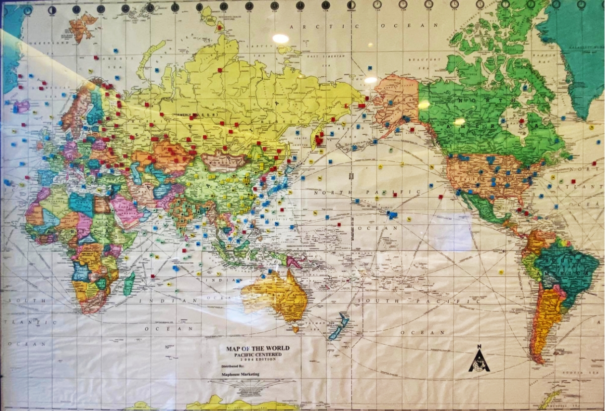

SECRETARIAT

**ANNEX C**

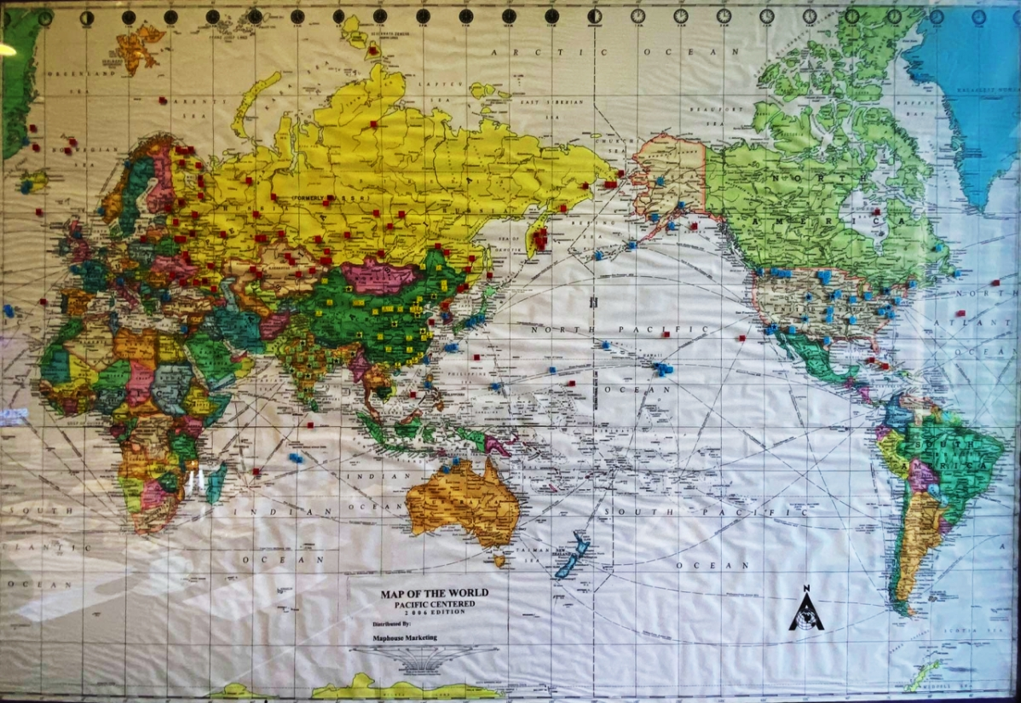

RED TEAM

**ANNEX C**

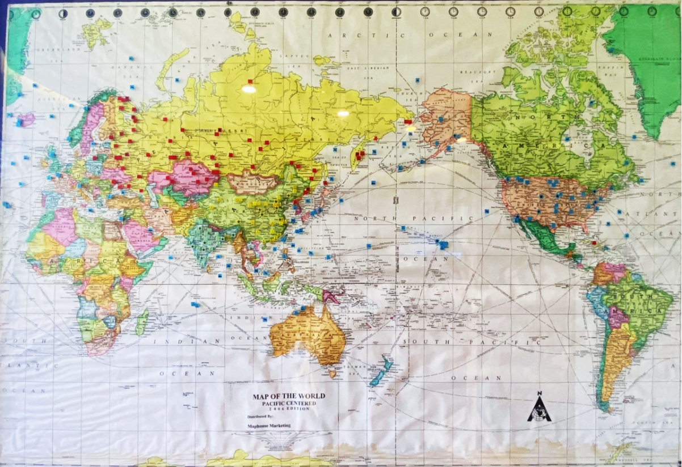

BLUE TEAM

**ANNEX C**

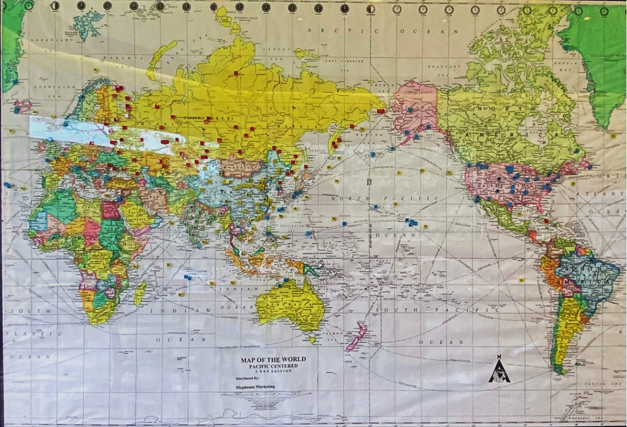

YELLOW TEAM

**ANNEX C**

**GREEN TEAM**

**TEMPLATES FOR COMMUNICATION ANNEX D**

**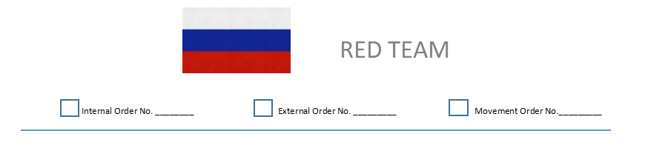**

**ANNEX D**

**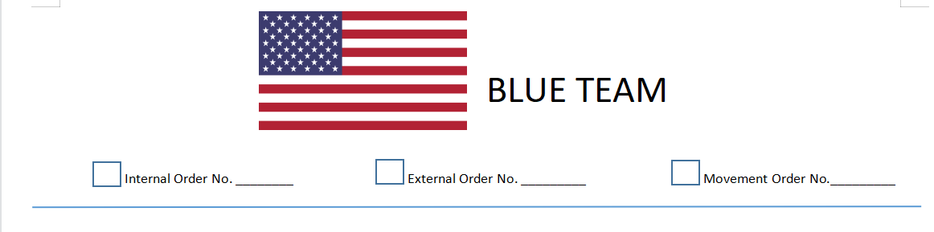**

**ANNEX D**

**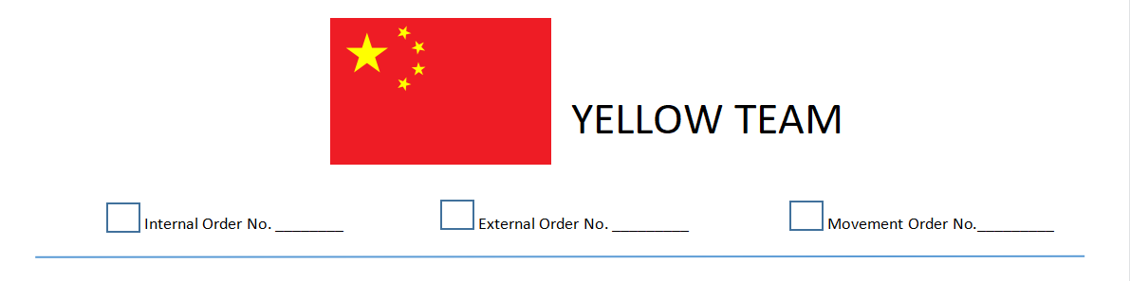**

**ANNEX D**

**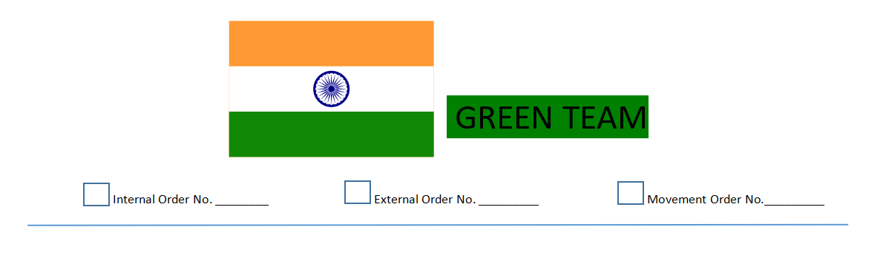**

**ANNEX E**

**NUCLEAR PLANT**

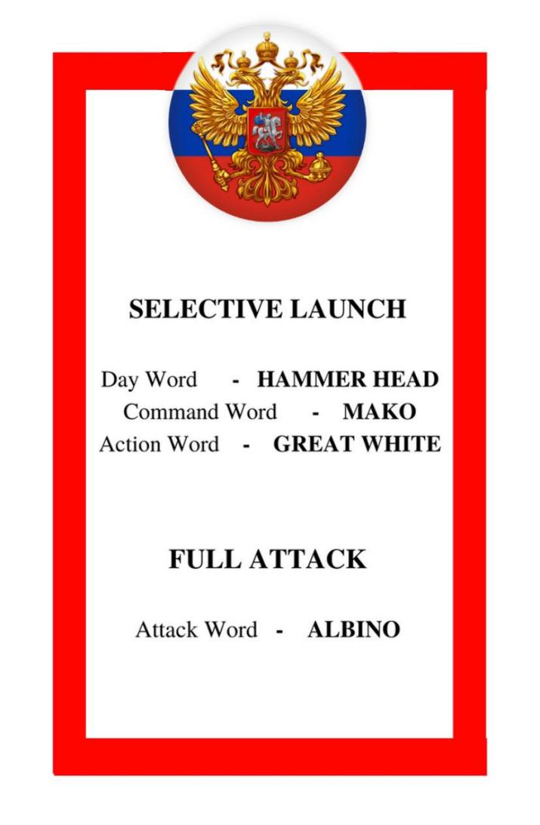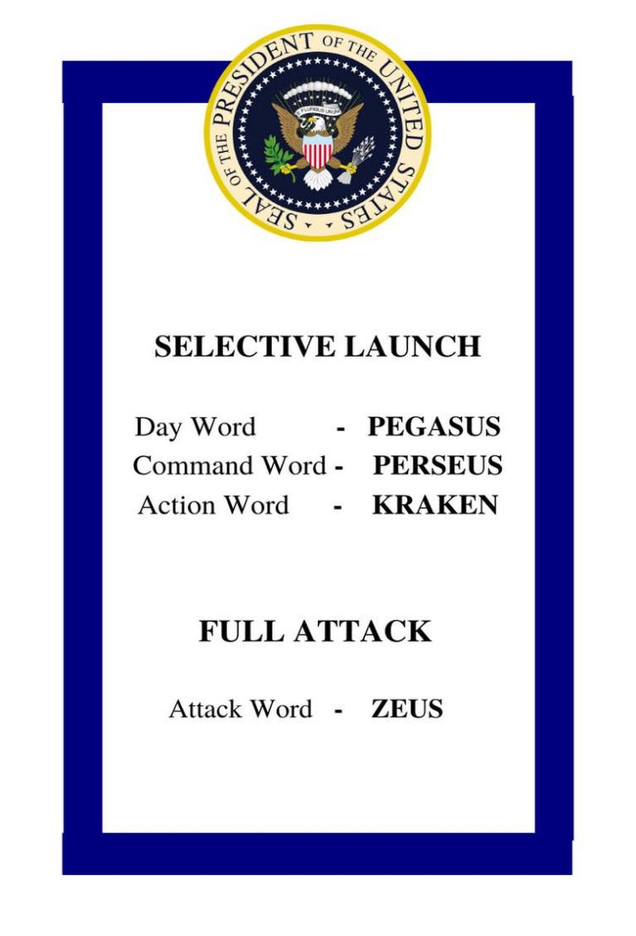**ANNEX F**

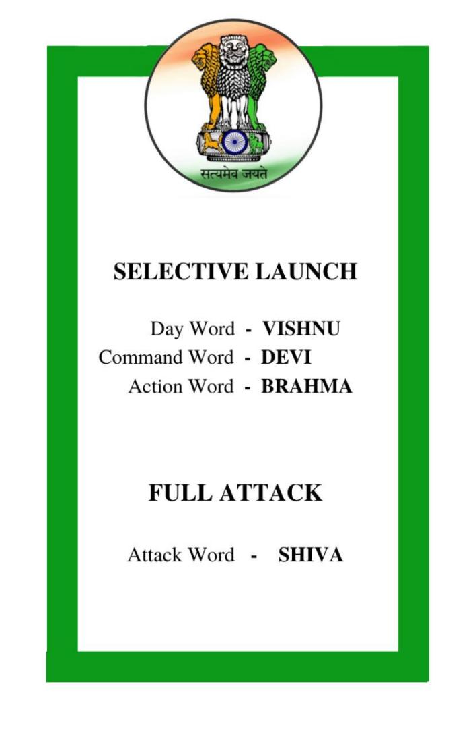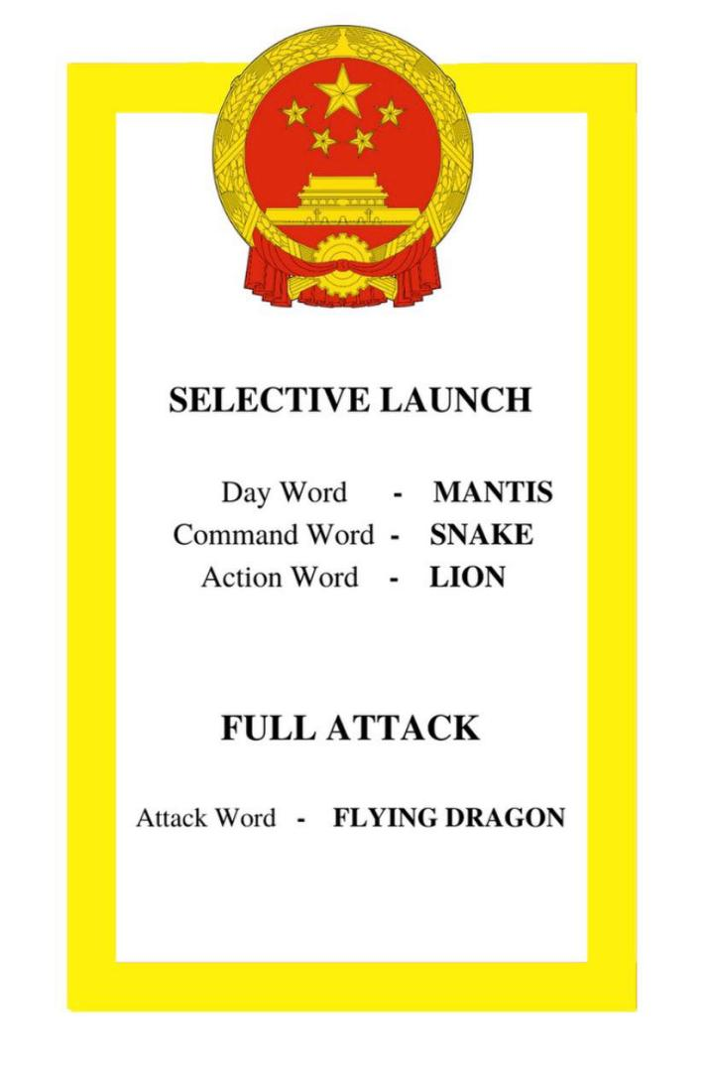

**XIV SECRETARIAT**

|  |  |  |
| --- | --- | --- |
| 1 | Facilitator | Mr. Anthony R. De Leon |
| 2 | Head Secretariat/Scenario Provider Clerk | Jasmin Prado |
| 3 | Scenario Provider Clerk | Liberthy Castro |
| 4 | Asst. Scenario Provider Clerk – Blue | Volunteer |
| 5 | Asst. Scenario Provider Clerk – Red | Volunteer |
| 6 | Asst. Scenario Provider Clerk – Yellow | Volunteer |
| 7 | Asst. Scenario Provider Clerk – Green | Volunteer |
| 8 | Head Plotter | Lian Mazarate |
| 9 | Blue Team Plotter | Jinno Mendoza |
| 10 | Red Team Plotter | Chris Padiernos |
| 11 | Yellow Team Plotter | Jerry Mabanta |
| 12 | Green Team Plotter | Edwin Tejada |
| 13 | Monitoring Officer (Plotting and Movements) | Abdulla Mastura |
| 14 | Movement Recorder | Lester Barozzo |
| 15 | Scorer | Jera Mae San Jose |
| 16 | Gofer | James Ripalda and |
| 17 |  | Goldy Magsanoc |

|  |  |  |
| --- | --- | --- |
|  | **Team Clerks** |  |
| 1 | Red Team | Liezel Manlunas |
| 2 | Blue Team | Lainelle Albeza |
| 3 | Yellow Team | Rosemarie Bote |
| 4 | Green Team | Arvie Joyce Ofiana |
| 5 | United Nations | Rya Caramat |

|  |  |  |
| --- | --- | --- |
|  | **Guest Psychologists** |  |
| 1 | Red Team | Andrew Macalma |
| 2 | Blue Team | Pauline Namoca |
| 3 | Yellow Team | Sally Maximo |
| 4 | Green Team | Faridah Wetherick |

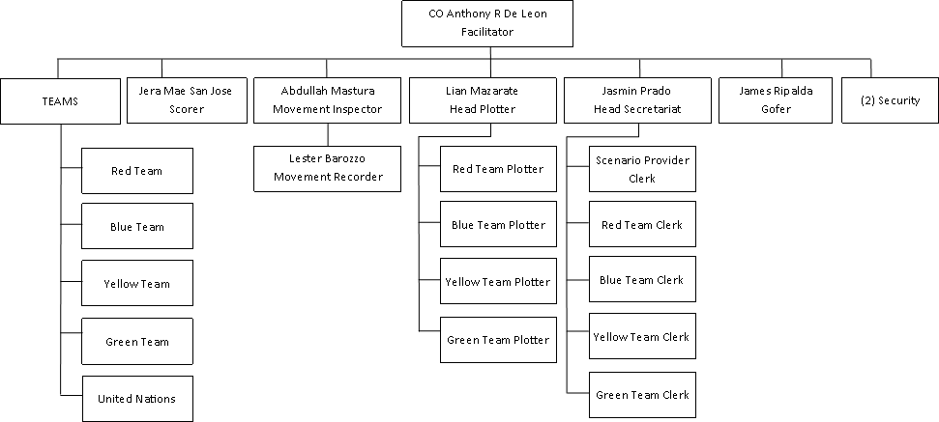

**REQUIREMENTS**

1. **SECRETARIAT**
2. Facilitator’s Manual
3. (2) laptops for (2) scenario provider clerks
4. (2) printers for (2) scenario provider clerks
5. (1) laptop for scorer
6. (1) laptop for Def Con to be projected on stage
7. 1 round table
8. (4) rectangular tables for working area for clerks
9. White board
10. 1 coffee & water station
11. 1 food station (menu to be given to sir ADL)
12. Timer/Clock
13. Extension cords
14. **TEAMS**
15. Handbook for each participant in binder
16. (1) laptop
17. (1) printer
18. (1) Clerk
19. 1 round table or 2 rectangular table as working area
20. 1 telephone
21. 1 rm short bond
22. Template with logo of each team
23. Name tags
24. 1 coffee & water station
25. 1 food station
26. Extension cords